# Cookbook to set up a Teradata Virtual Machine in Azure

## Introduction

In October 2018 Teradata announced a major transformation and reorganization of the company. As part of these changes, they announced [Teradata Vantage](https://www.prnewswire.com/news-releases/teradata-vantage-the-platform-for-pervasive-data-intelligence-empowers-enterprises-to-analyze-all-the-data-all-the-time-300726595.html) as their Data Warehouse solution for the cloud. This new product replaces the Teradata Database on Azure.

This post is a Quick Start Guide to set up a Teradata Virtual Machine in Azure and to connect to it. Some of the steps shown in this document can be used to setup a VMWare virtual machine too or connect to a physical system.

Detailed documentation can be found [here](https://www.teradata.com/Products/Cloud/Do-it-yourself/Azure). The [Teradata Database on Azure Getting Started Guide](https://docs.teradata.com/reader/hTsEyN_i68VbDI3JhMo_fw/5eLh4OvblUtFTBIkzkF4Nw), the [Teradata® Software for Azure Installation and Administration Guide](https://docs.teradata.com/reader/r8Re~v8Ba1Zv7HzUZLku3A/M1uxxL1GLHDrwdev9F8F9g) and [Teradata® Viewpoint Installation, Configuration, and Upgrade Guide for Customers](https://docs.teradata.com/reader/tLZdyFuJ6~R98CJ9_COugQ/ywE8LIwplMOi_Gq7JDBhzQ) are particularly useful resources.

Arsen Vladimirskiy posted an [useful video](https://youtu.be/R4nobcH1vs4) which shows some of the processes described in this document. It was recorded prior to Teradata Vantage, when you had Teradata Database available on the Azure Marketplace. However, many of the steps shown in this video are still valid.

## Launch a Teradata Virtual Machine (+ Viewpoint)

Logon in [Azure portal](http://portal.azure.com/), and click on “Create a resource”.

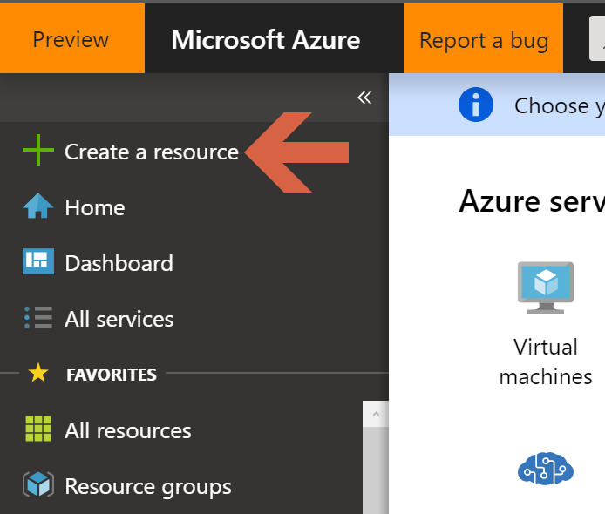

Search for “Teradata” and click on “Teradata Vantage”.

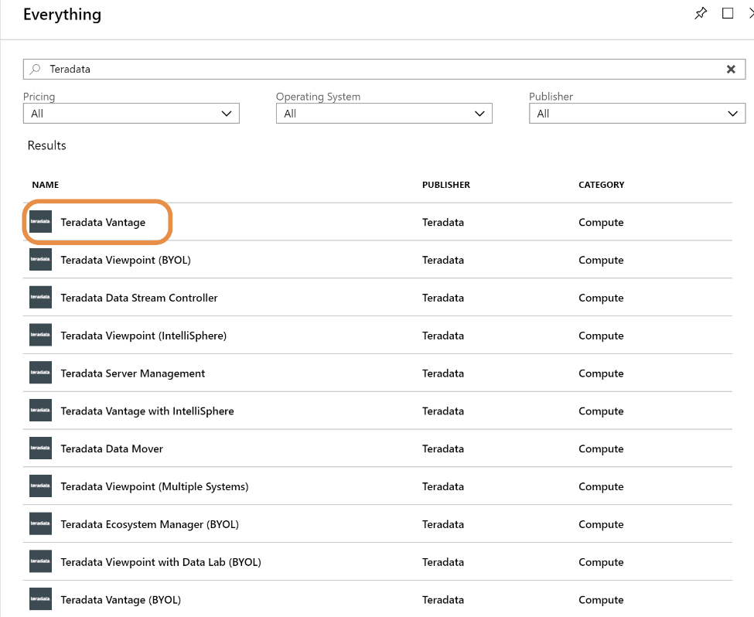

Click “Create”.

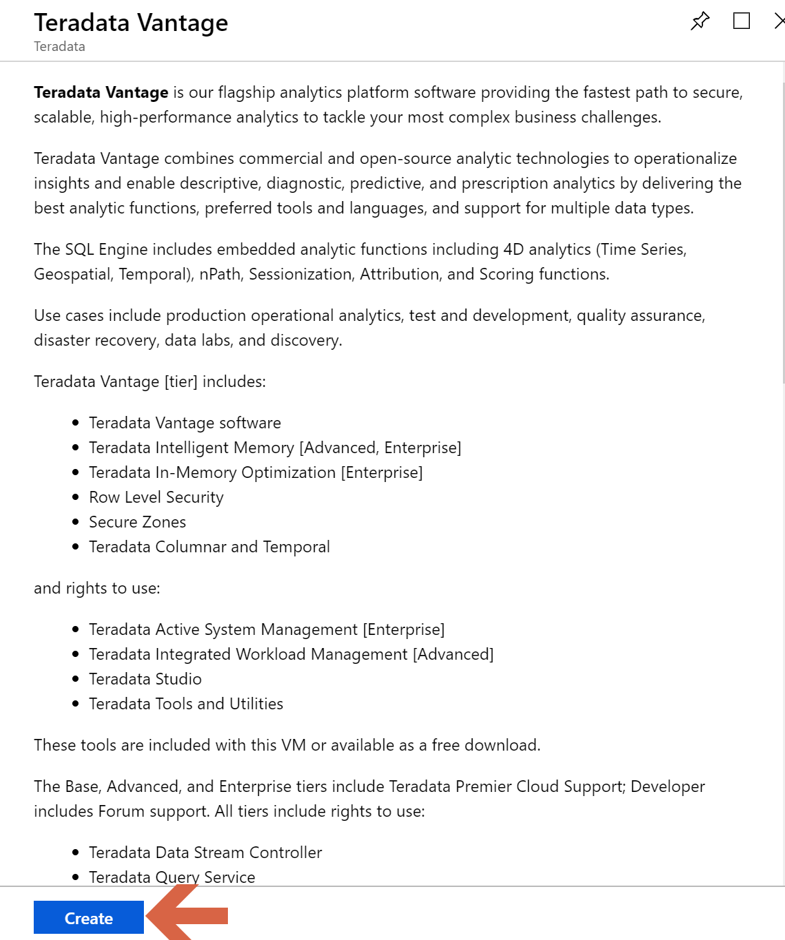

Define the user at Operating System level (Linux), set a password, and decide in which Resource Group Teradata Vantage is going to be. Carefully select the Location where you are going to launch the Teradata environment, as the virtual machine types you require may not exist in all Locations.

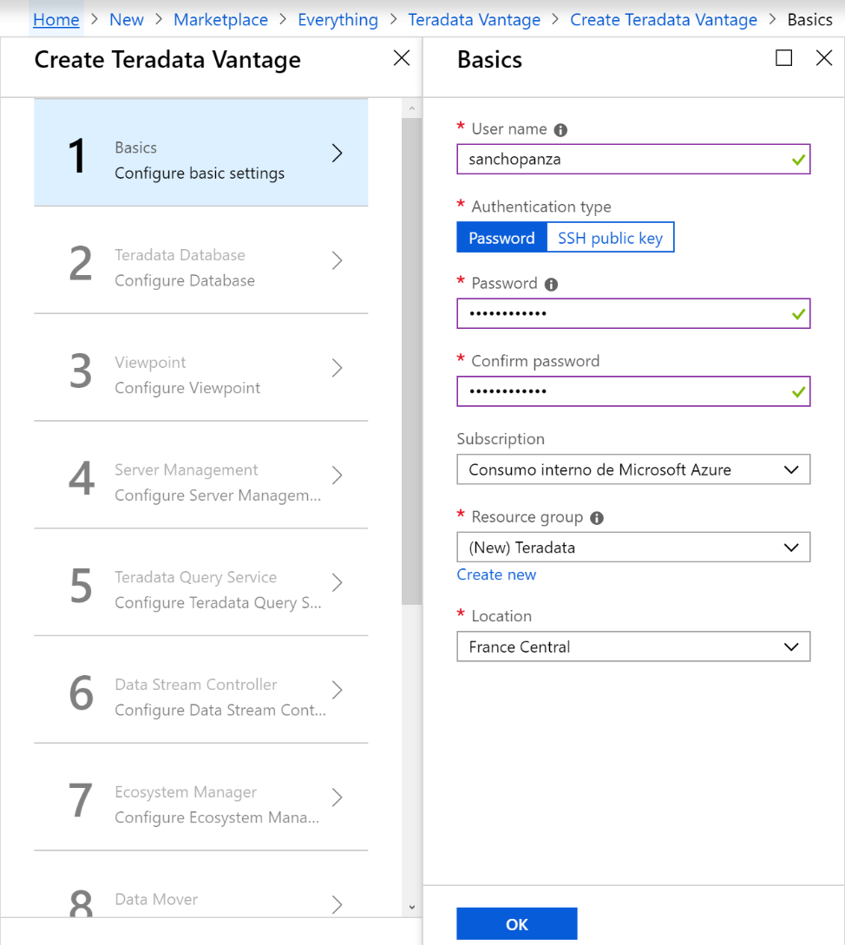

On the next screen, you must carefully choose the DBC password (as it is the super-user for the database) and keep it, as well as the number of nodes, disk size and virtual machine size as per your requirements. The database tier represents the level of features you get, and the price you pay for the database. You can leave the rest as default values.

All Teradata tiers require we pay license fees for the software, and our Azure subscriptions may be limited to use the Marketplace. We are going to use a Developer tier in this guide, as it doesn’t require to pay software licenses and we can launch it in our personal Azure subscription. However, we are going to show how to fill up the form in this screen afterwards for an Enterprise tier as it is slightly different.

So, if we want to launch a Developer tier:

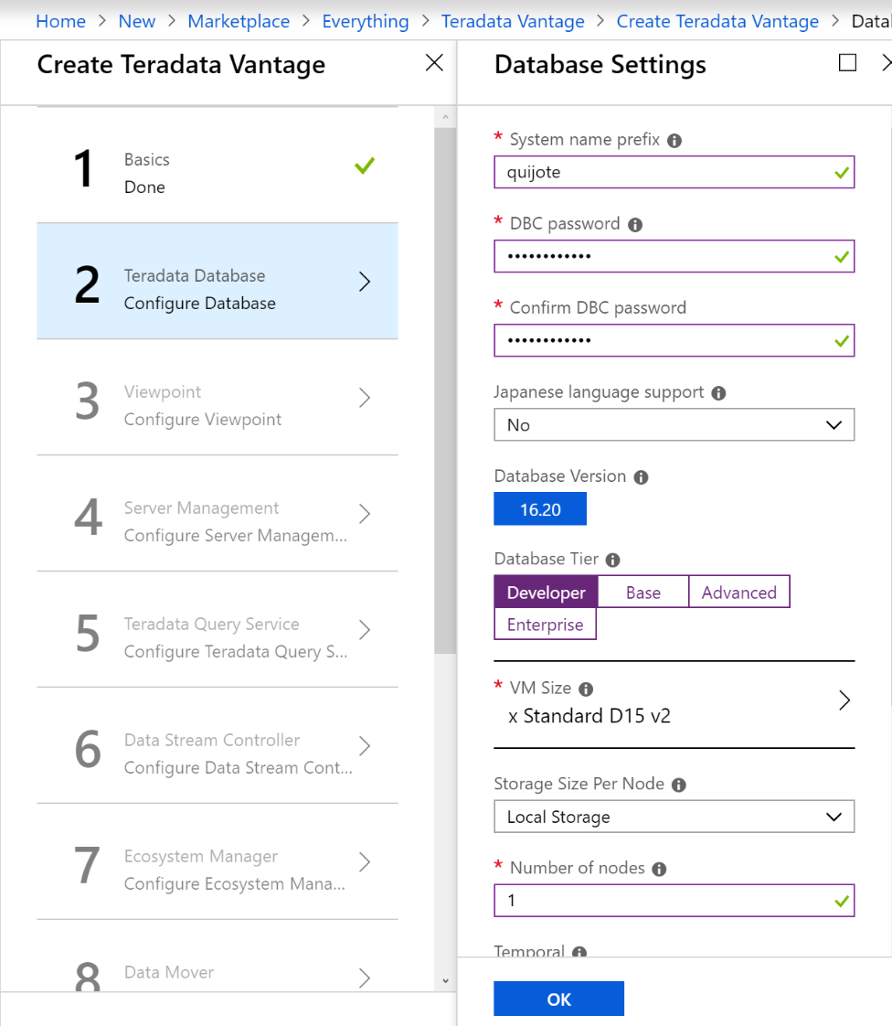

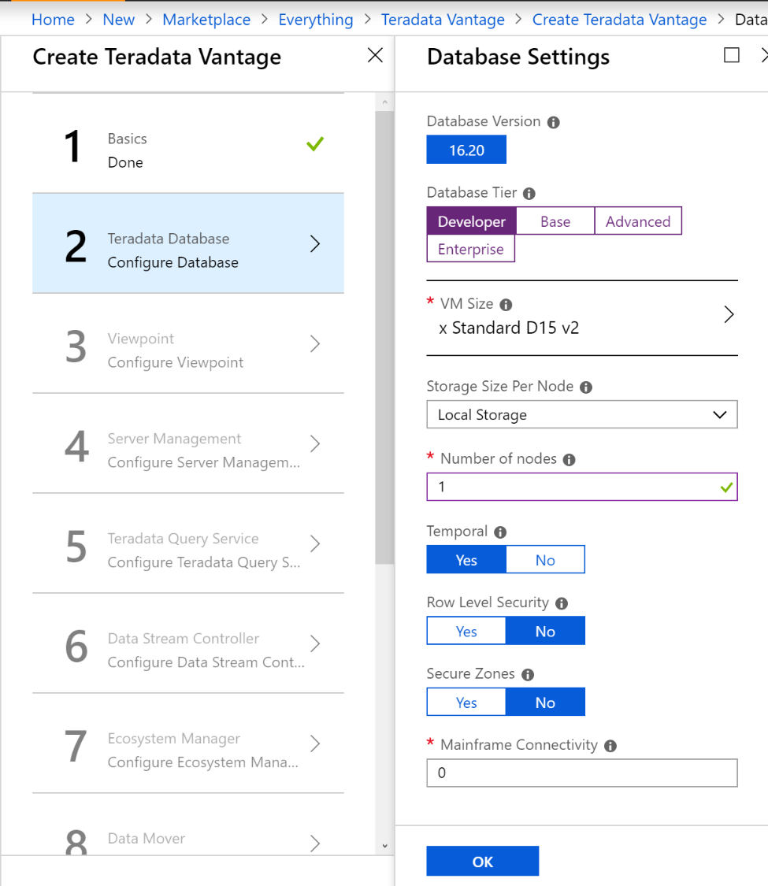

As an example, the next 2 screens correspond to launching an Enterprise tier.

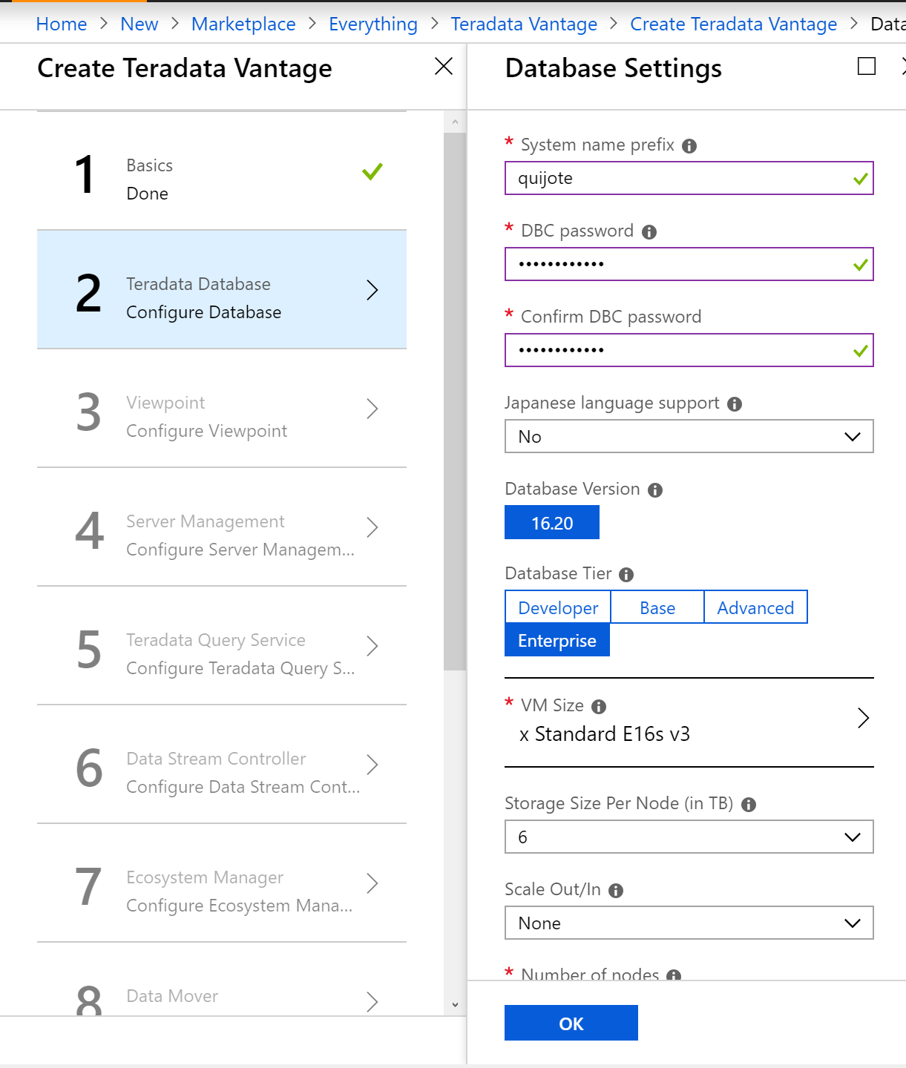

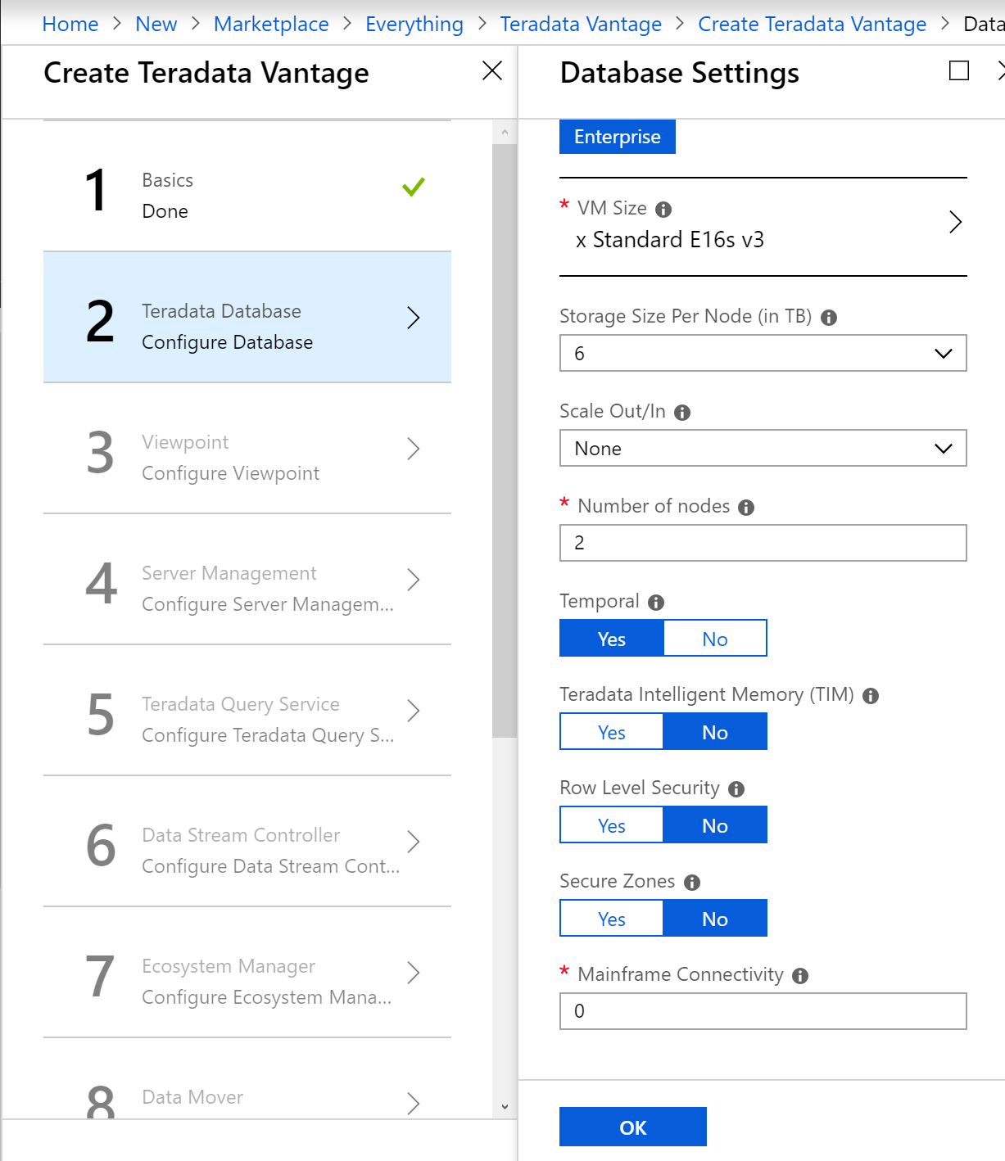

The next screens to launch a Teradata Vantage are the same, independently of the tier. We used a Development tier to write this guide, as we didn’t have permissions to use other tiers in our subscriptions.

Viewpoint is a separate server which is used to monitor, configure some aspects of the database and do some housekeeping tasks. You can create a Teradata Vantage database without Viewpoint, and work with it, but the Viewpoint server may simplify many tasks, so it is better to create and configure it.

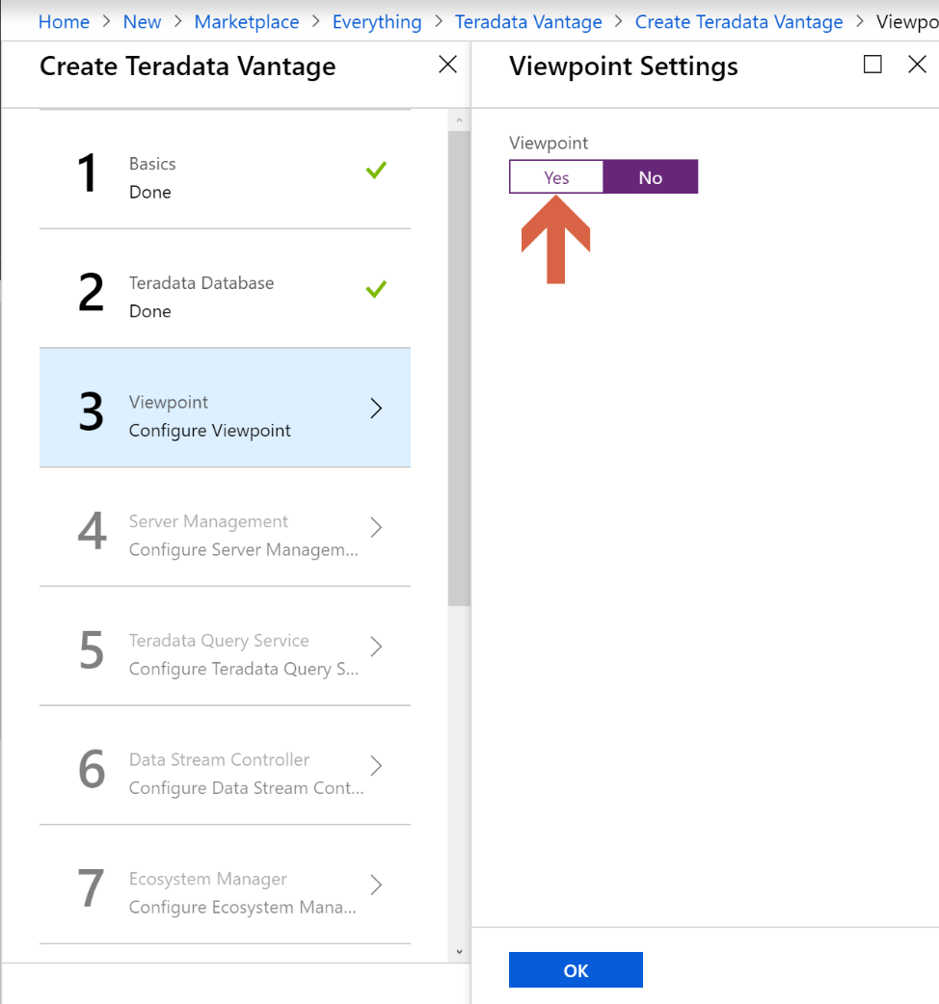

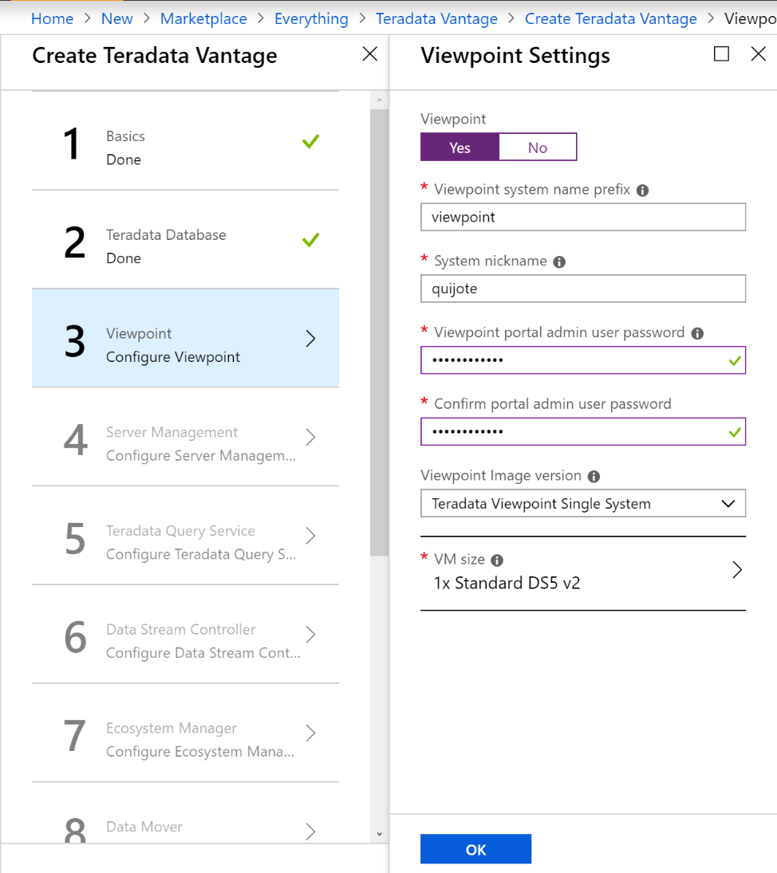

Server Management allows the Teradata Customer Service team to connect to the system and perform the tasks required by the customer as per the Support contact. We don’t need it.

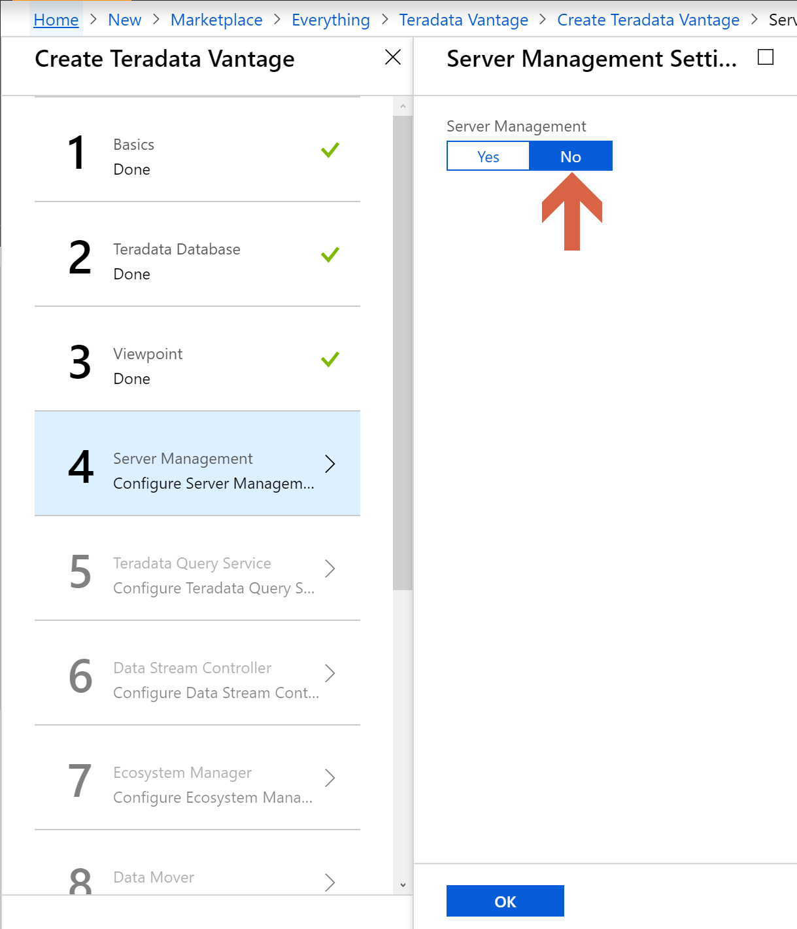

We won’t setup Teradata Query Service, Data Stream Controller, an Ecosystem Manager server, a Data Mover one, nor QueryGrid.

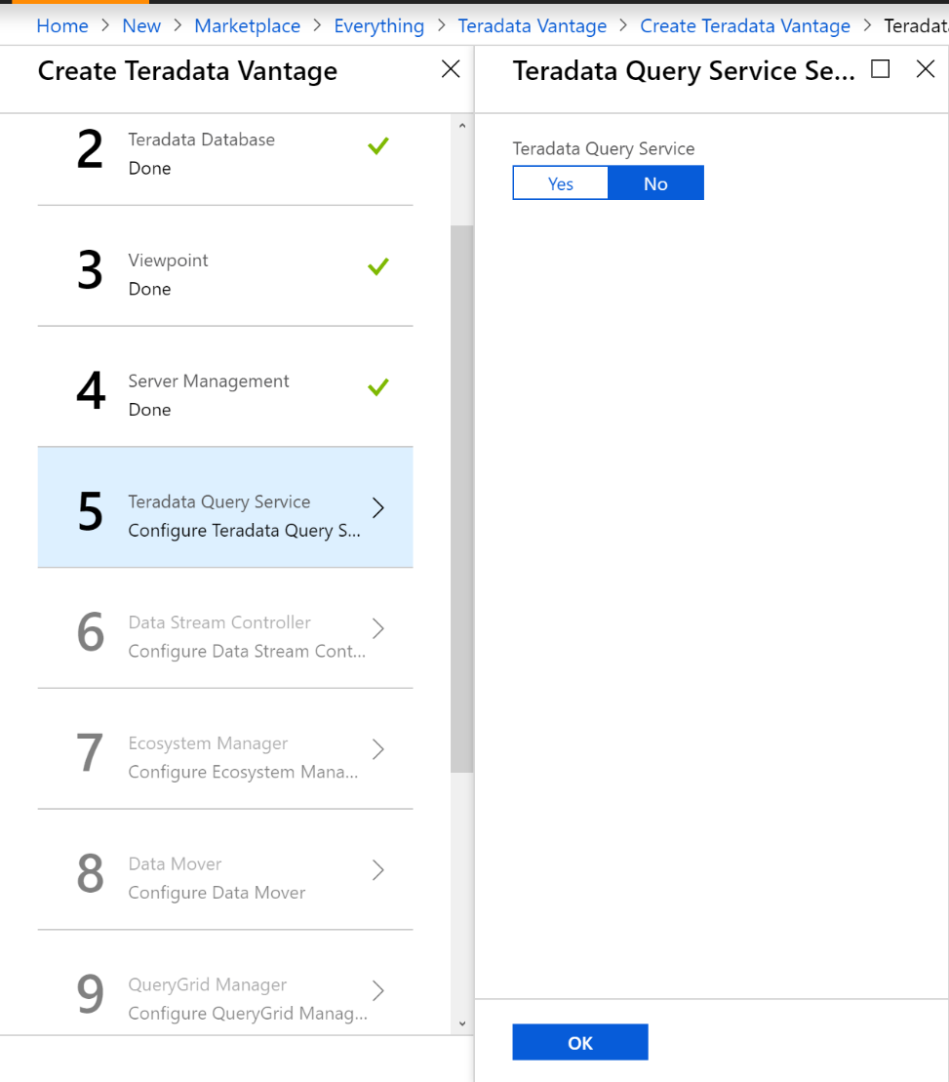

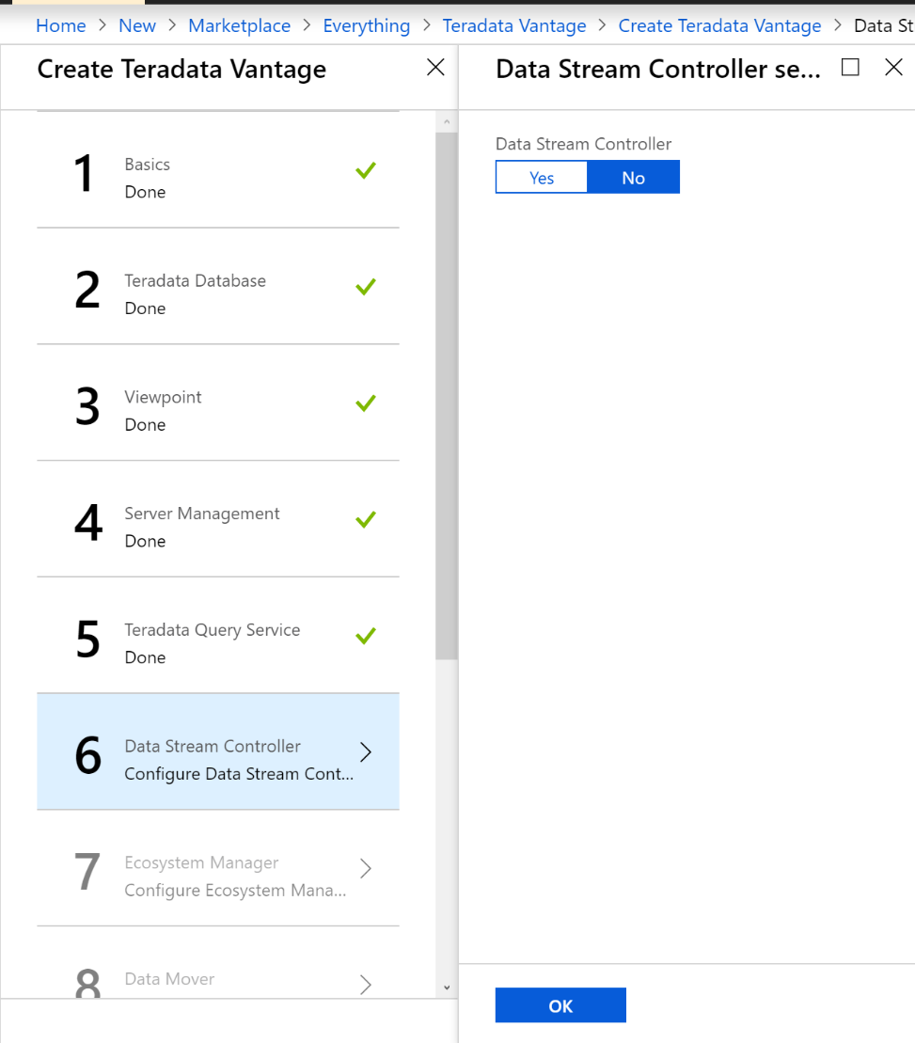

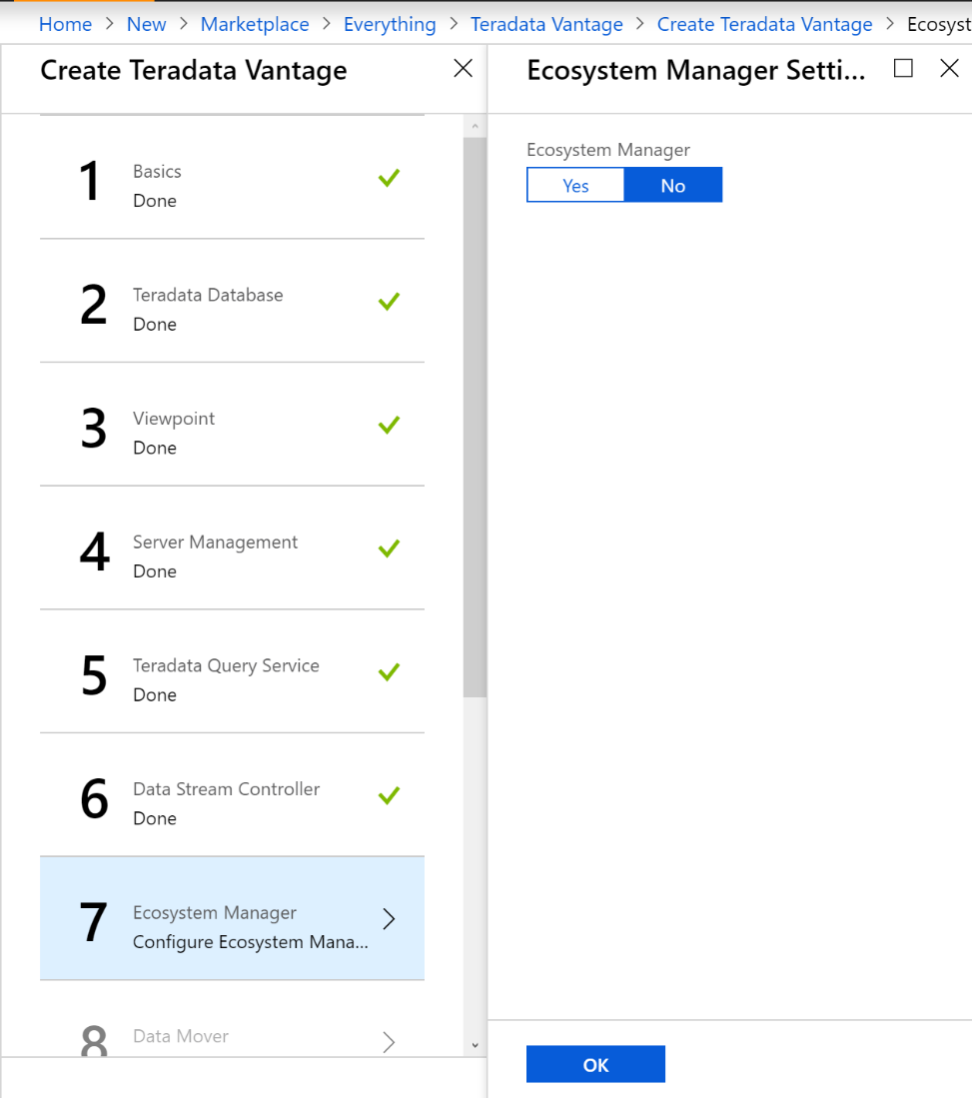

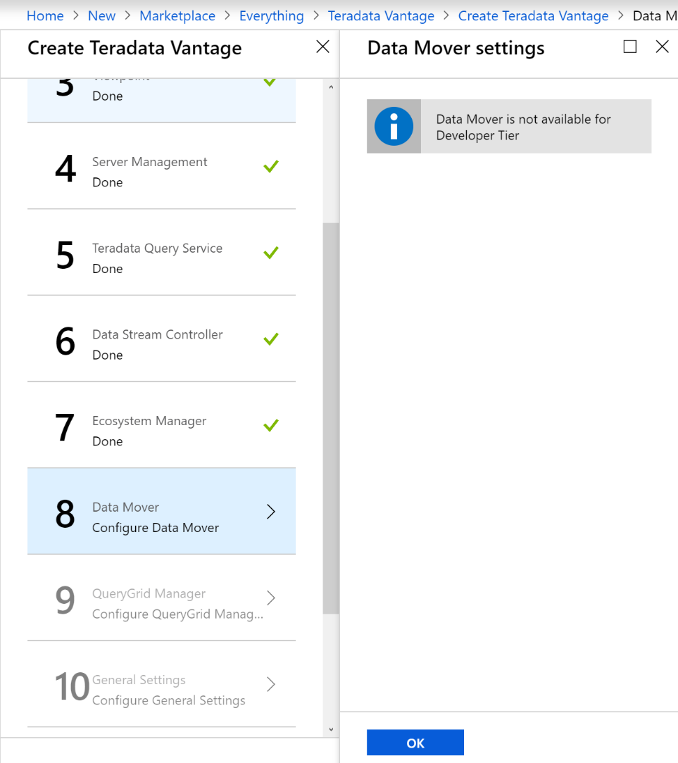

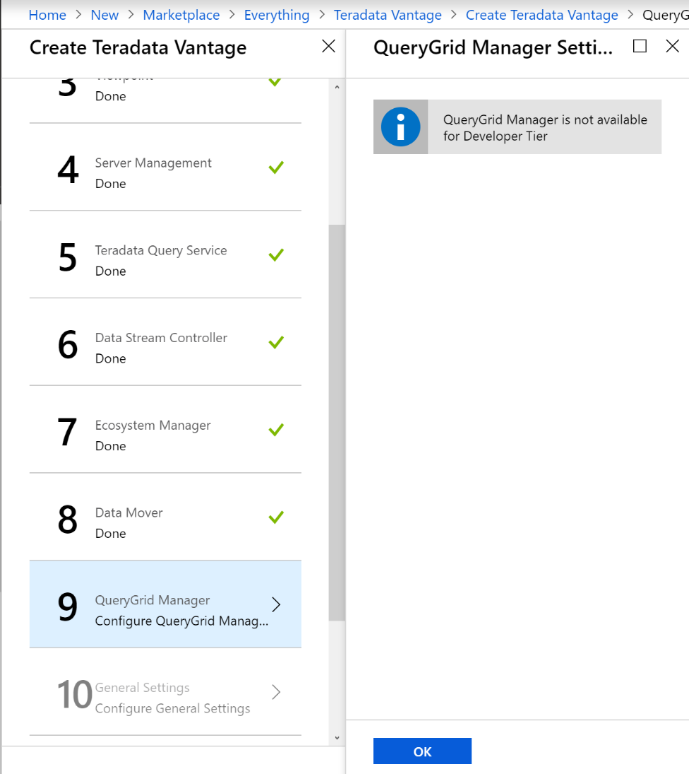

Review the general settings.

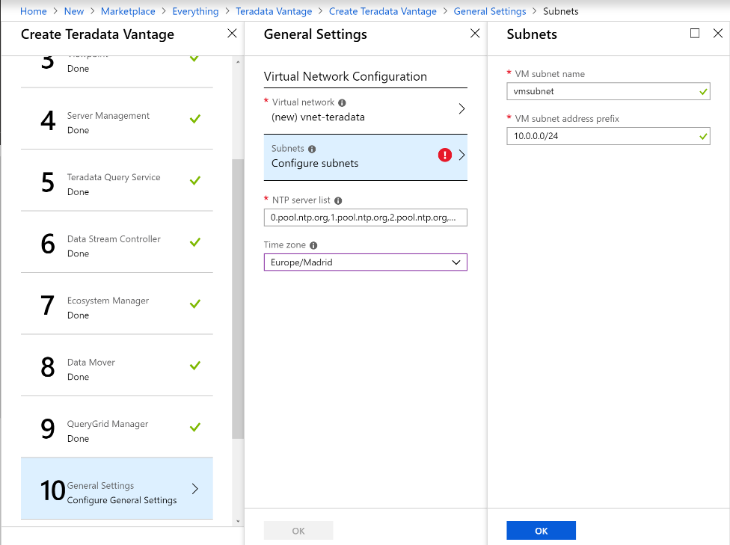

Review the Summary and click OK:

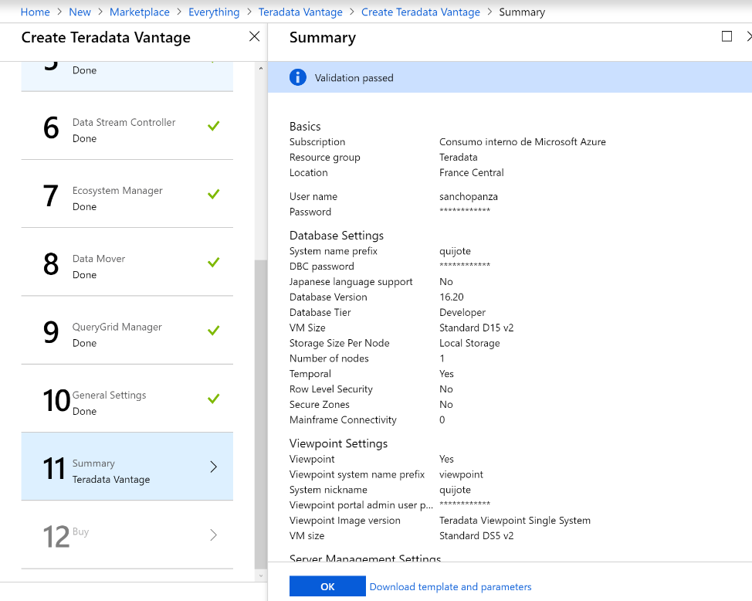

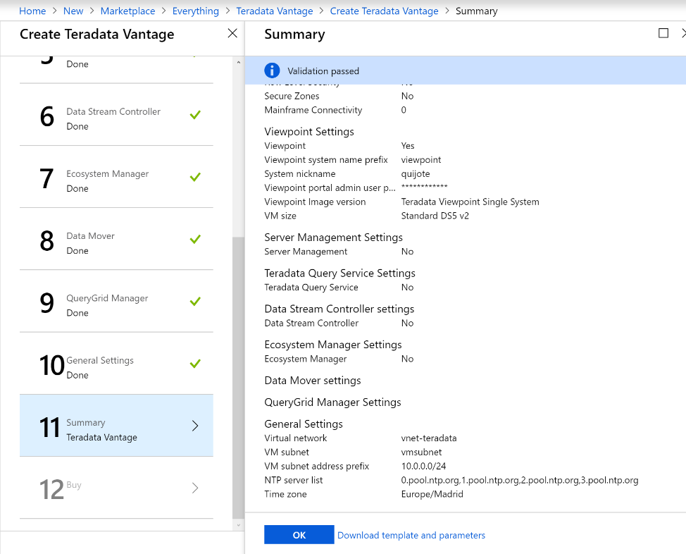

Then we review the Terms of use and click “Create”.

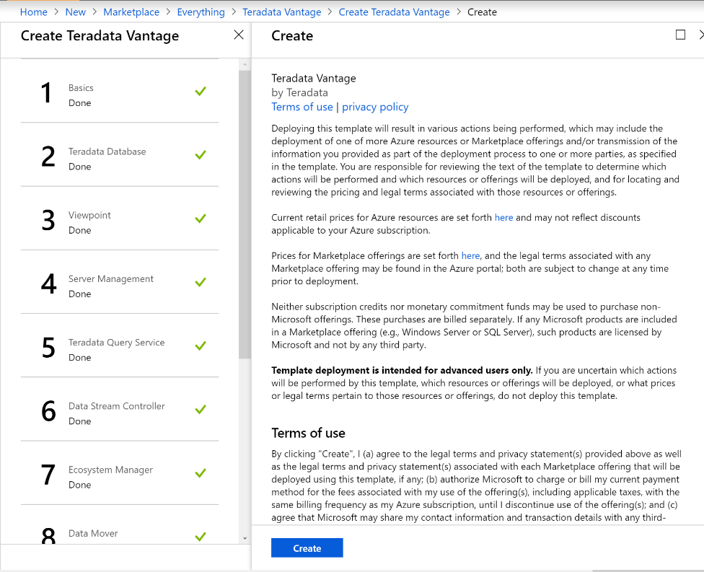

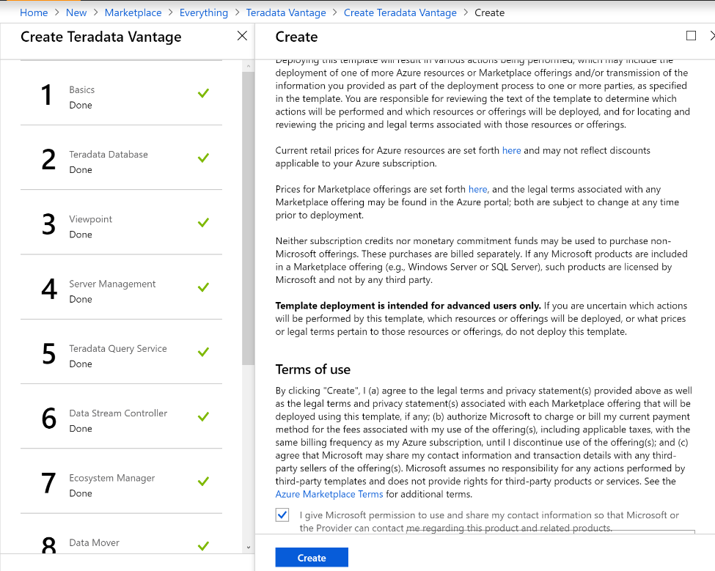

The deployment of Teradata Vantage and Viewpoint will start, and it will take 30-40 minutes to complete. When it finishes, your resource group will look like this:

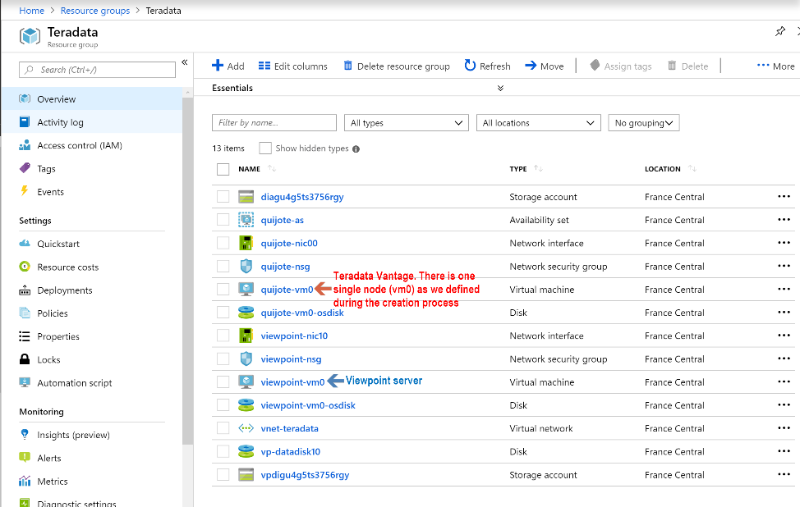

## Public IPs

When you deploy Teradata Vantage products in Azure using a solution template as we did in section 2, private IPs are assigned within the same VNet or VNet peering, but public IPs are not created.

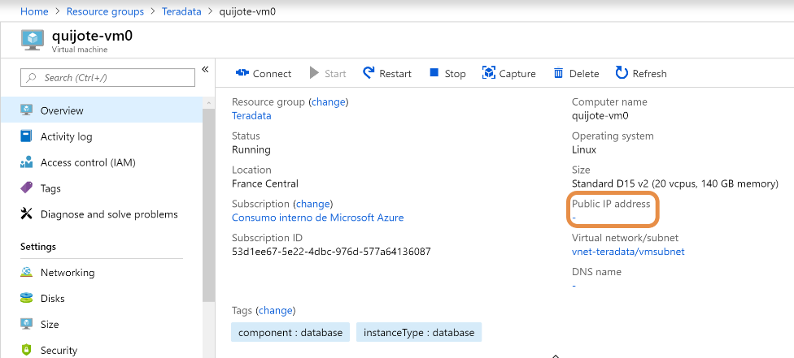

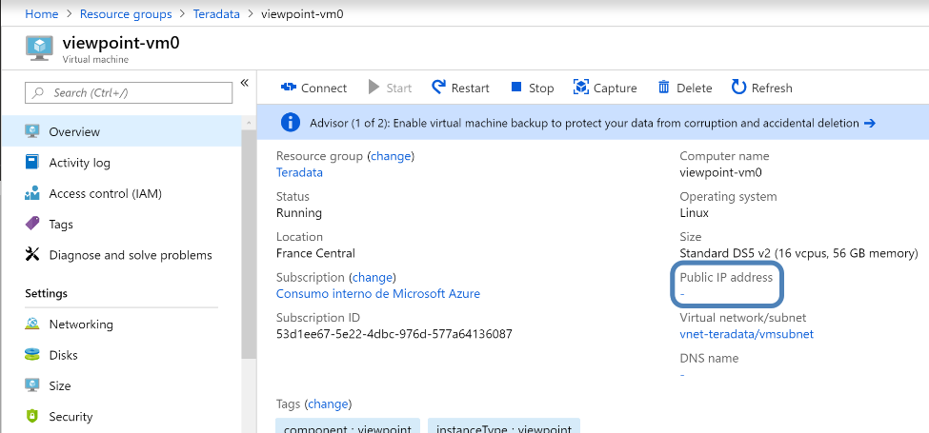

If we want to connect to the Teradata systems through Internet, we need to create public IPs and assign them to Teradata Vantage and Viewpoint virtual machines.

First, we go “Create a resource”.

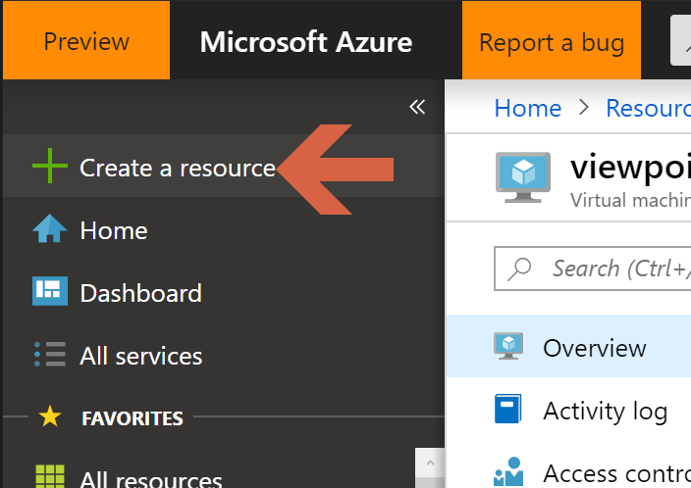

Search for “Public IP address”.

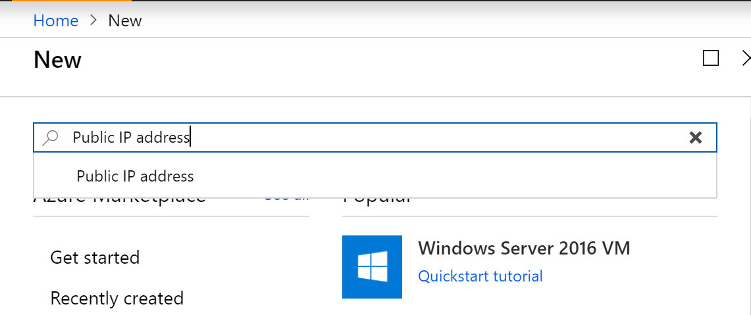

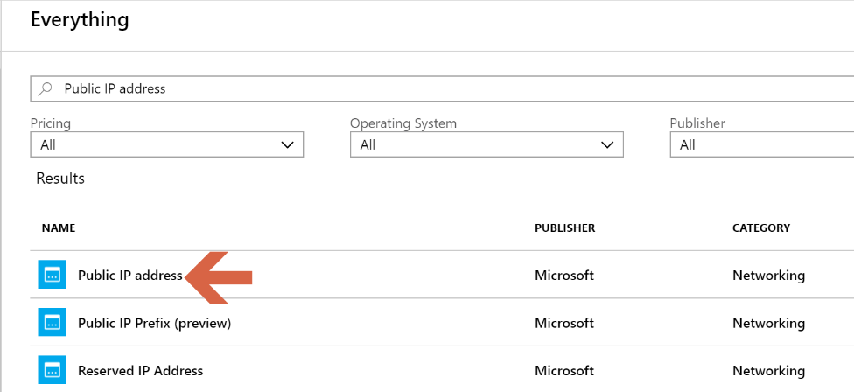

Click “Create”.

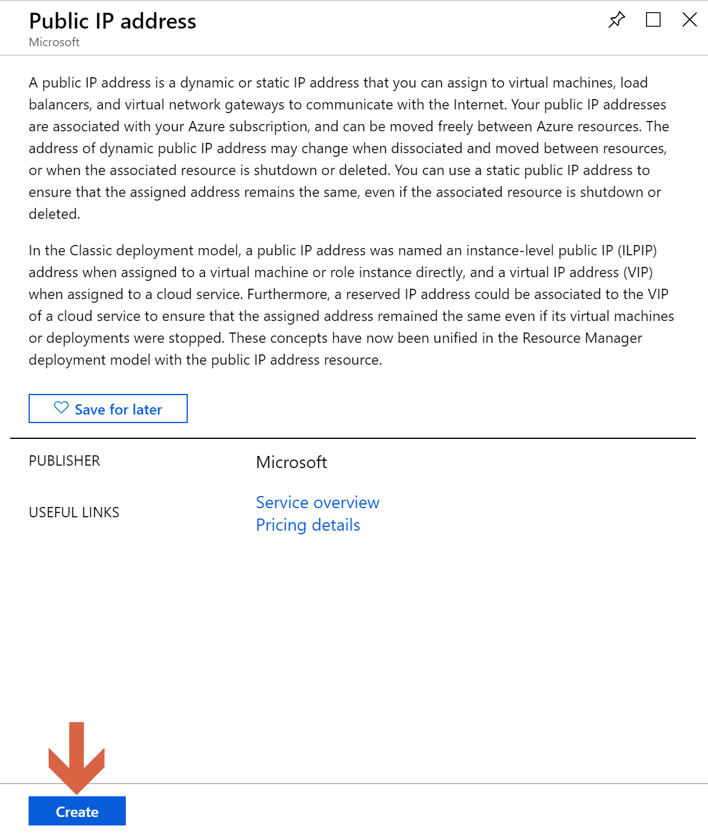

Provide the information for the public IP, and click “Create”.

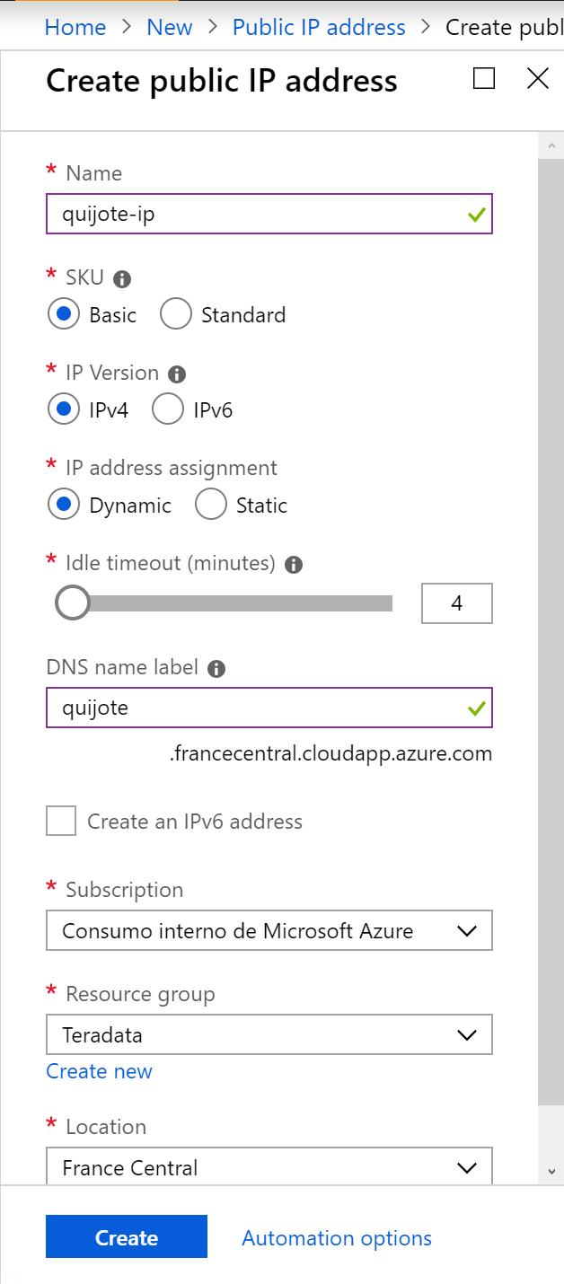

We come back to “Create a resource” to create the second public IP.

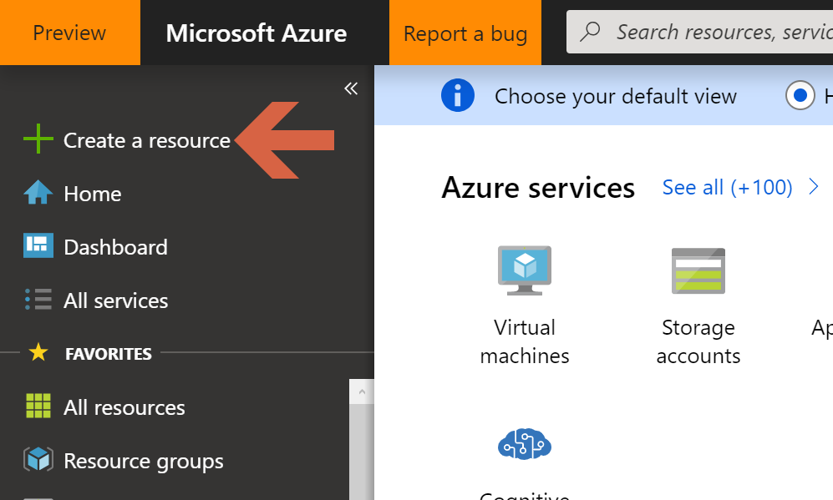

Search for “Public IP address”.





Click “Create”.

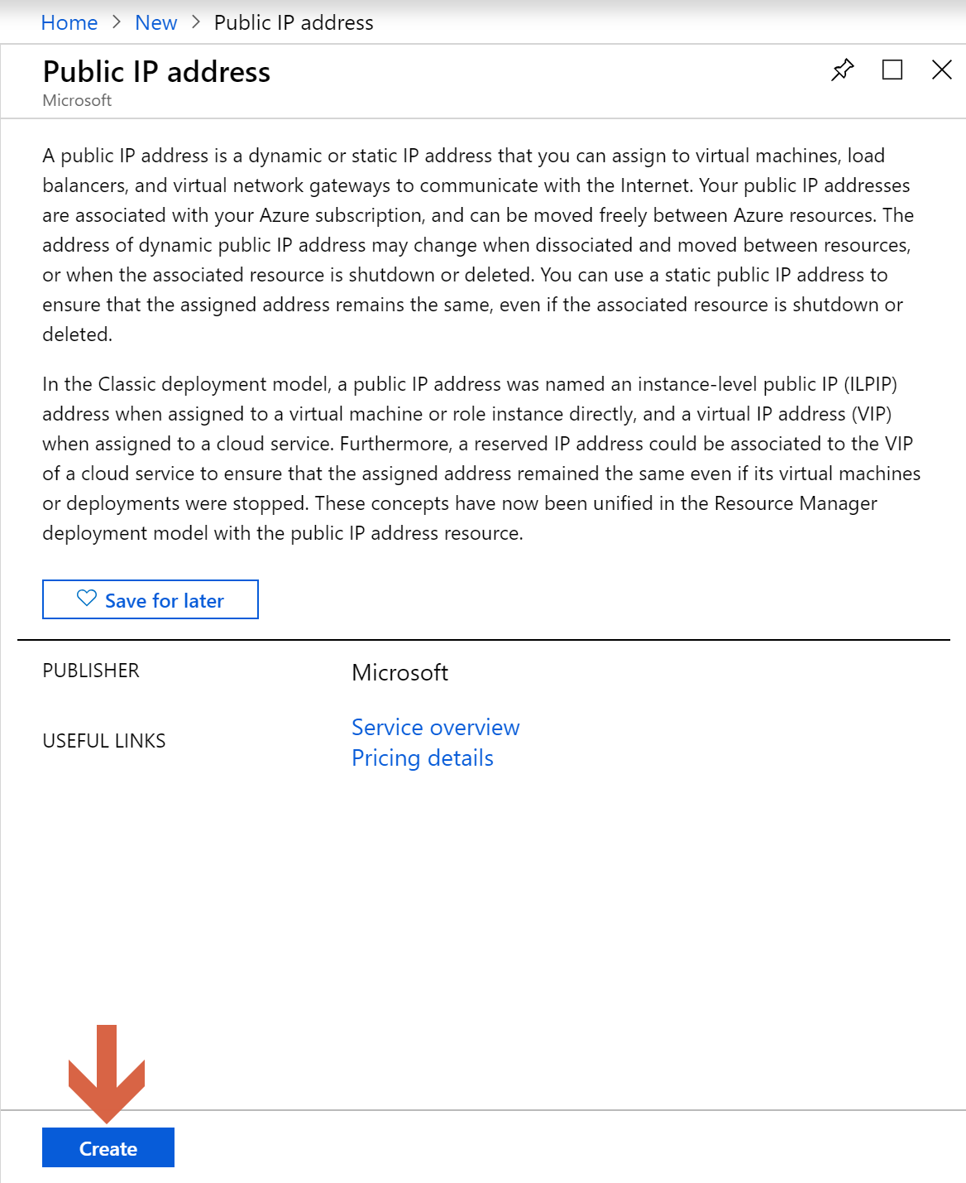

Provide the information for the public IP and click “Create”.

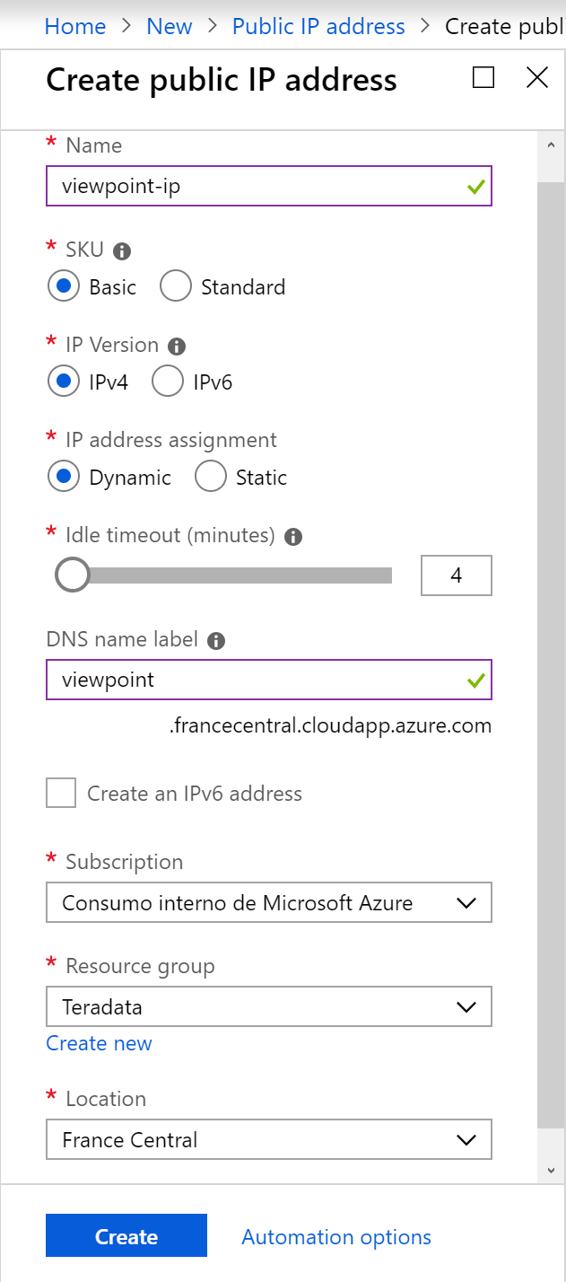

After creating the two public IPs, the resource group looks like this:

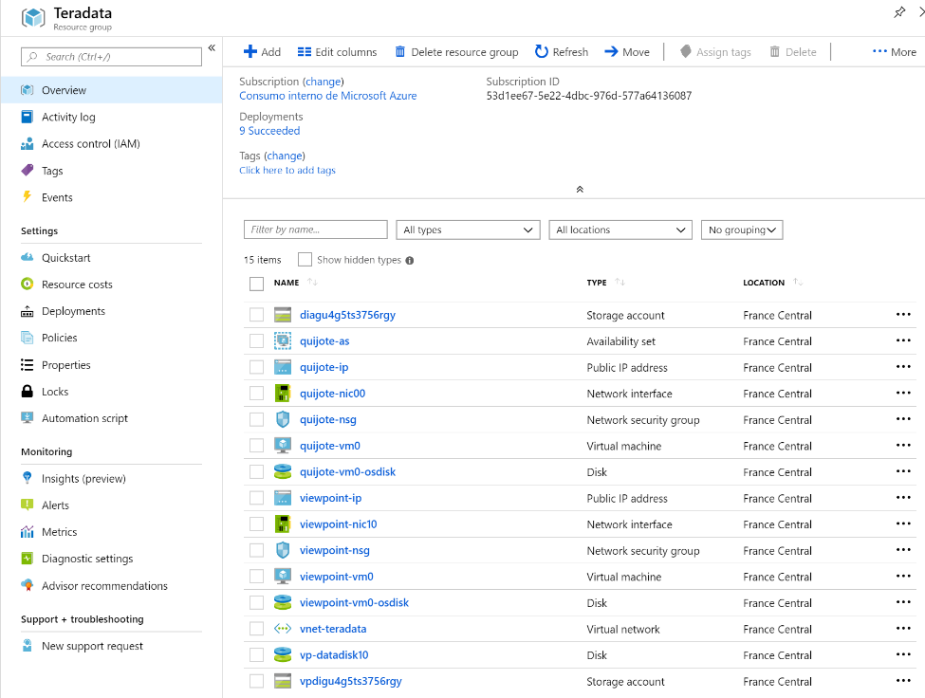

Select quijote-ip and click on “Associate”.

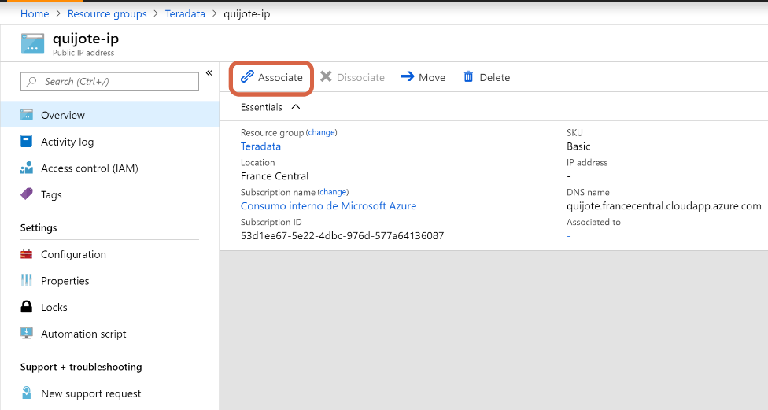

We select “Network interface” as resource type and choose the network interface quijote-nic00.

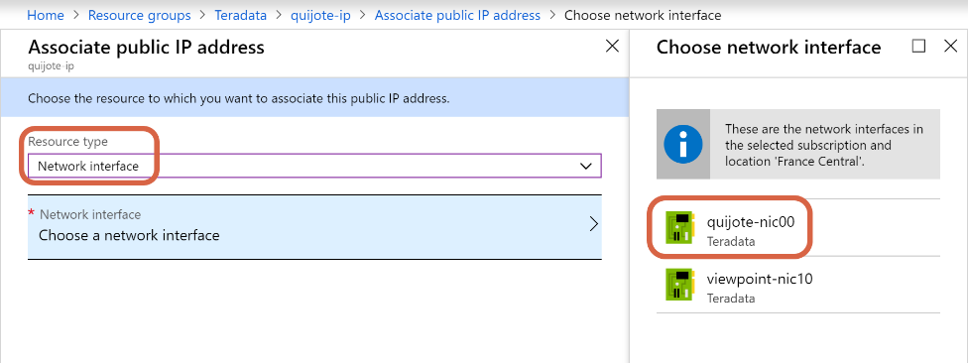

Click OK.

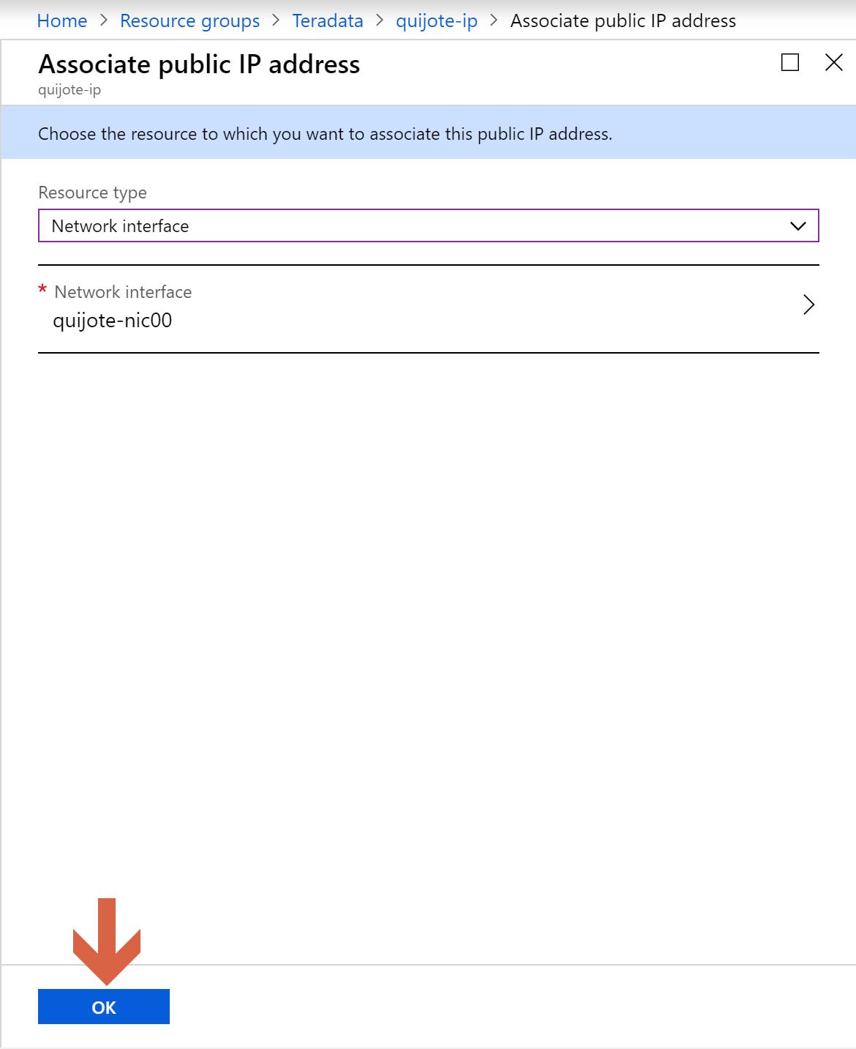

Now let’s select viewpoint-ip in the resource group and click on “Associate”.

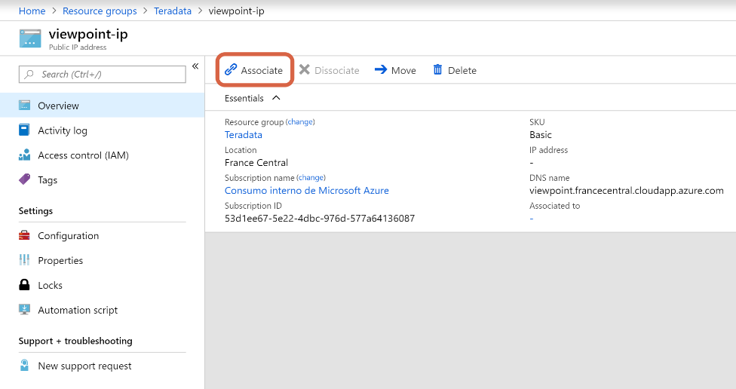

We select “Network interface” as resource type, and choose the network interface viewpoint-nic10

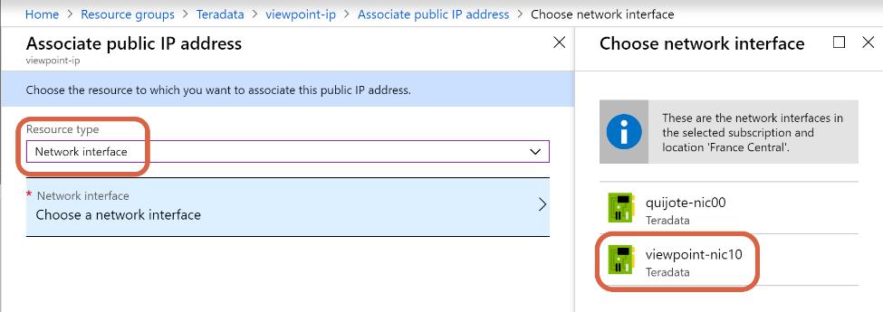

Click OK.

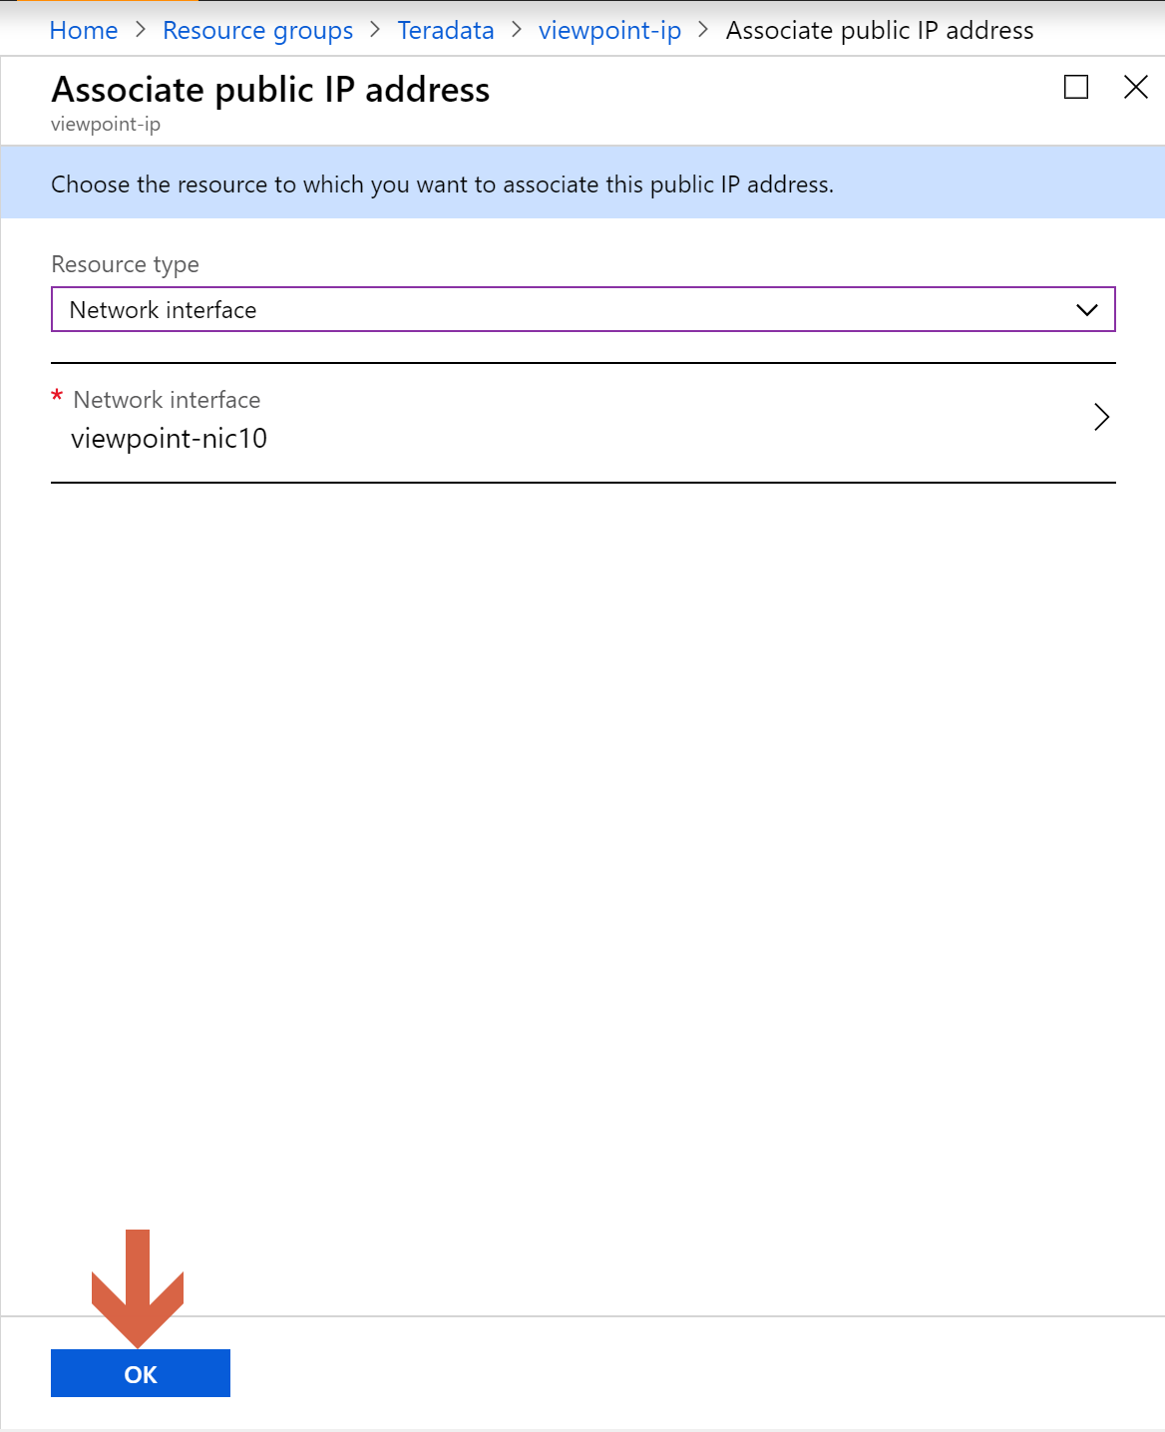

## Connect to Teradata Vantage with Teradata Studio Express

We go to Teradata Vantage virtual machine in the Azure portal and select “Networking”.

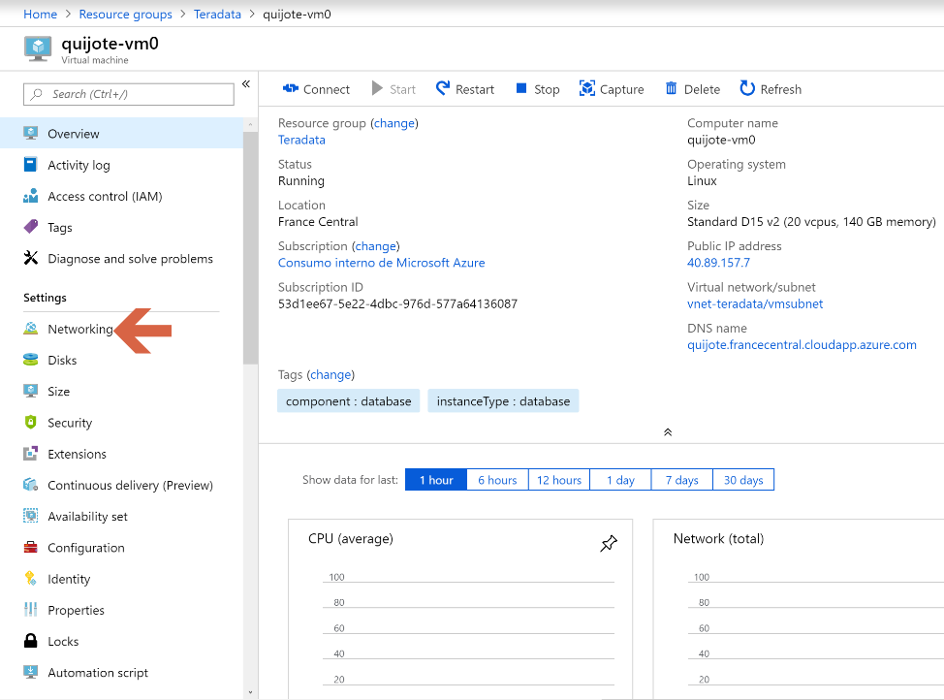

Click on “Add inbound port rule” in quijote-nic00.

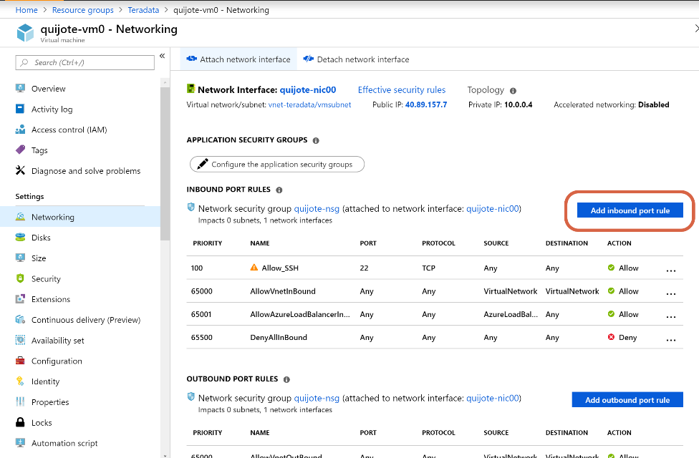

We open port 1025 for protocol TCP.

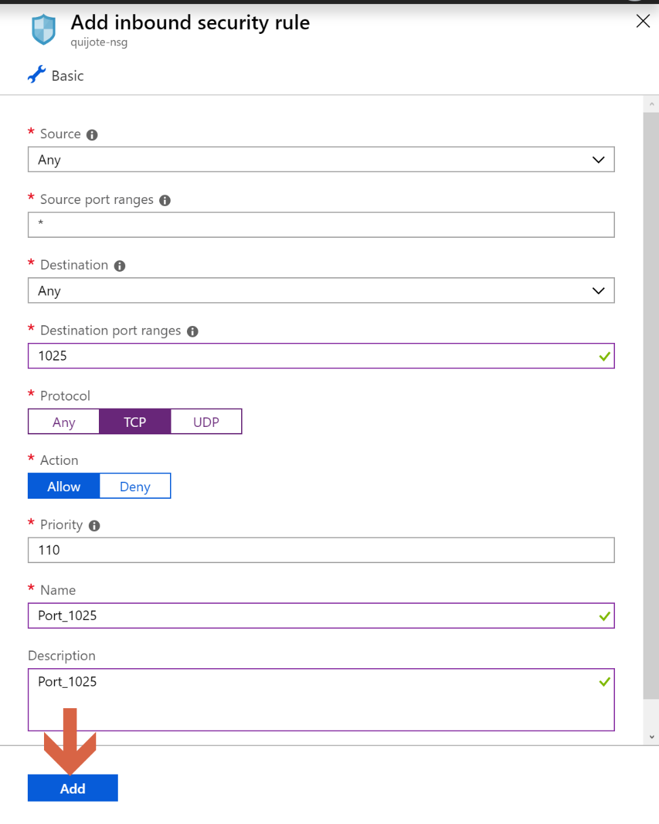

In your laptop, open a browser and navigate to [downloads](http://downloads.teradata.com/) in [Teradata Community](https://community.teradata.com/). Click on [Teradata Studio Express](http://downloads.teradata.com/download/tools/teradata-studio-express), and choose the version that better suits you. It should be the same as the Teradata Vantage version you have deployed in Azure, and if you have a 32 or 64-bits system. In this guide, we are going to install Teradata Studio Express 16.20.09.00 for Windows x86 64-bit.

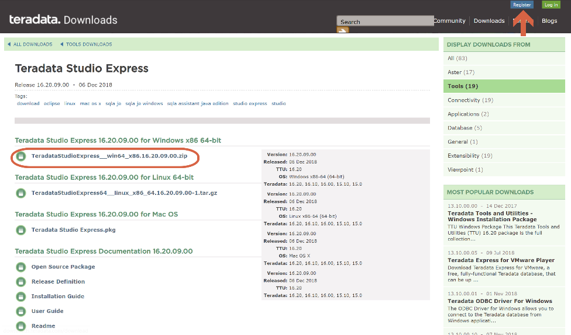

When you click on the link of the Teradata Studio Express version you choose, you’ll have to log in. If you don’t have a user for Teradata Community yet, register in the button shown in the screen above. Anyone is entitled to do it.

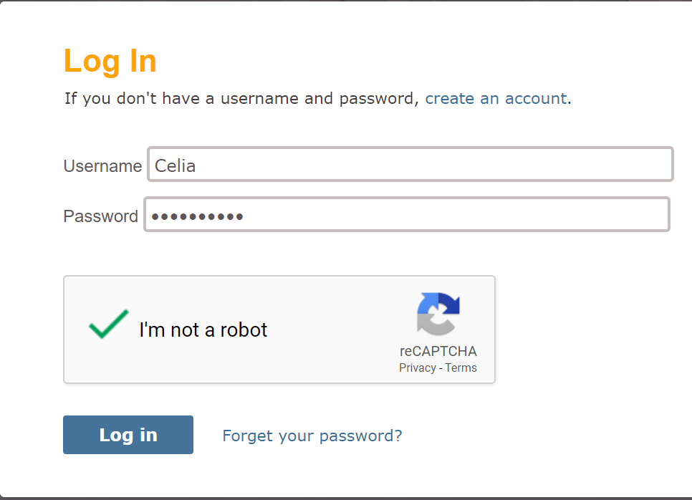

Scroll down to the bottom of the License Agreement, and click on “I Agree”.

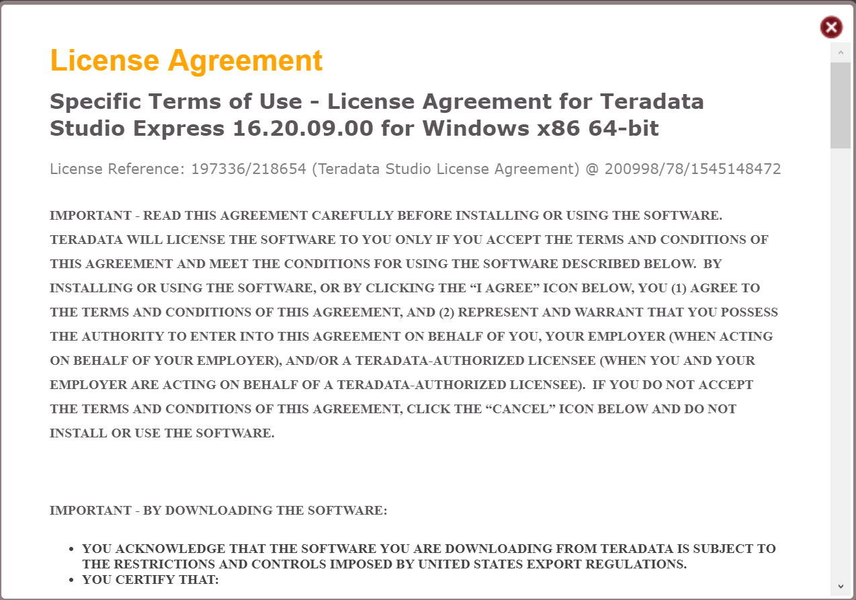

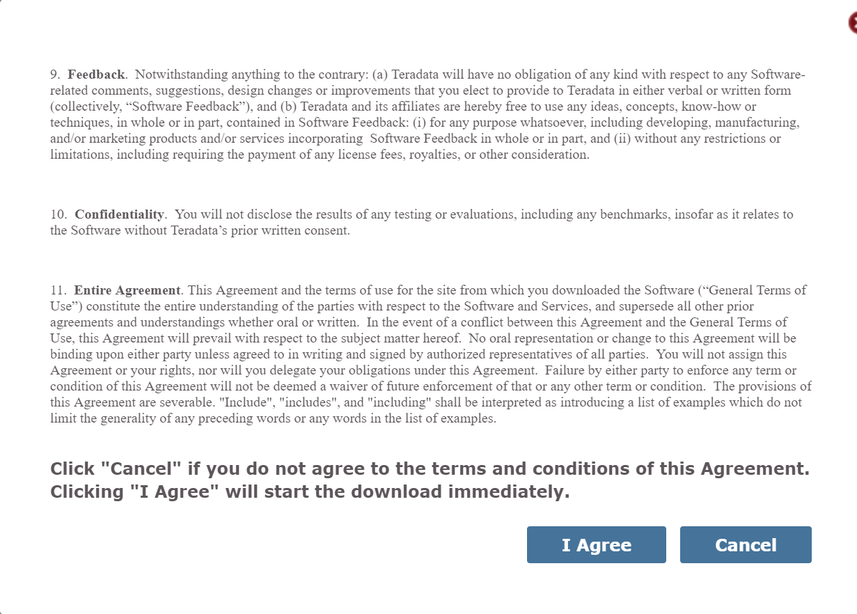

Save the file to a location on your computer, and unzip the file you downloaded to a directory on your laptop.

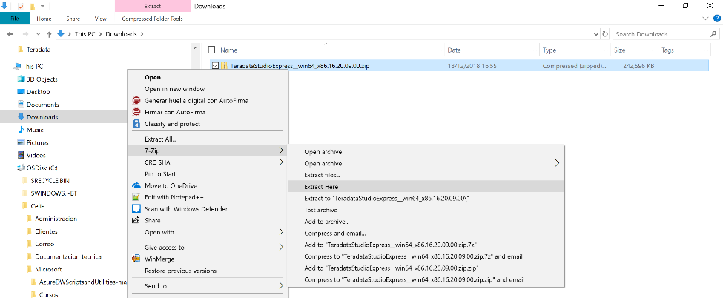

Teradata Studio Express is a Java client. If you don’t have it yet, you need to install Java Runtime Environment (JRE).

Go to the folder where you unzip Teradata Studio Express, and execute setup.exe

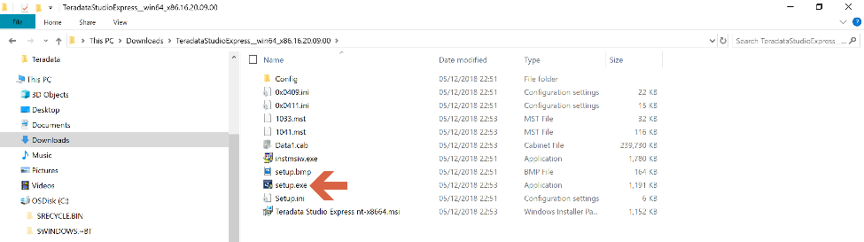

Run the program and follow the instructions.

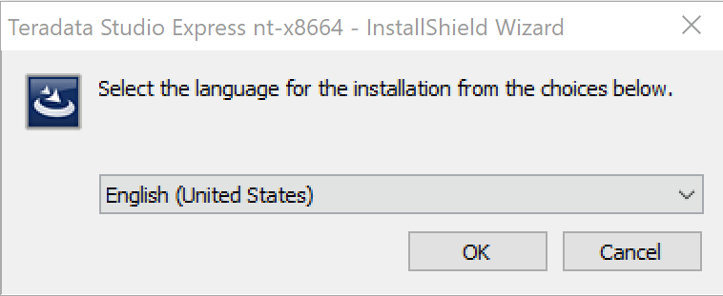

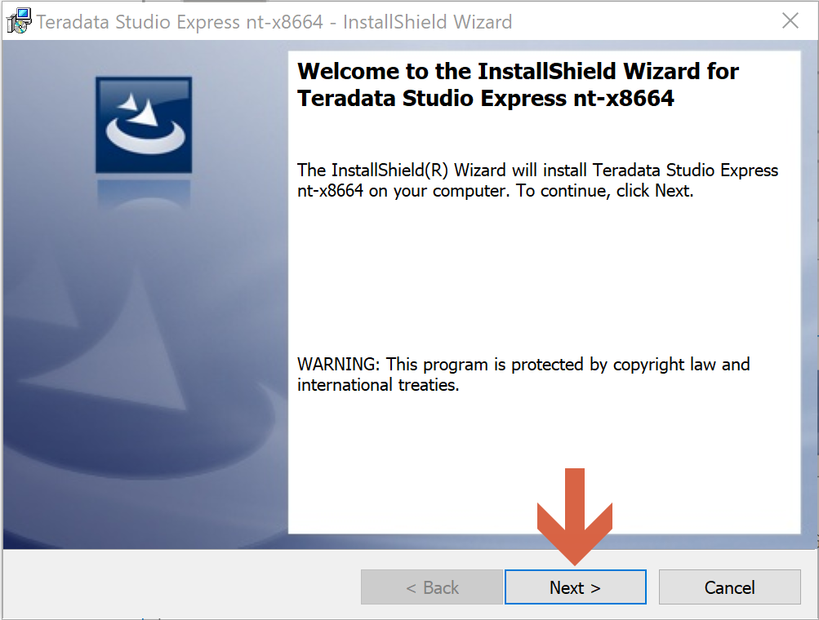

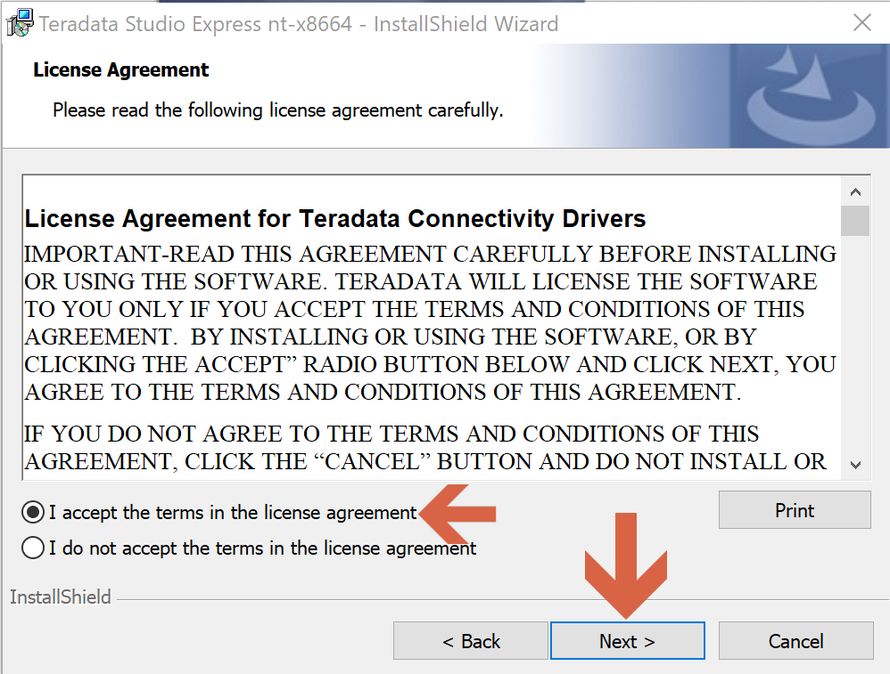

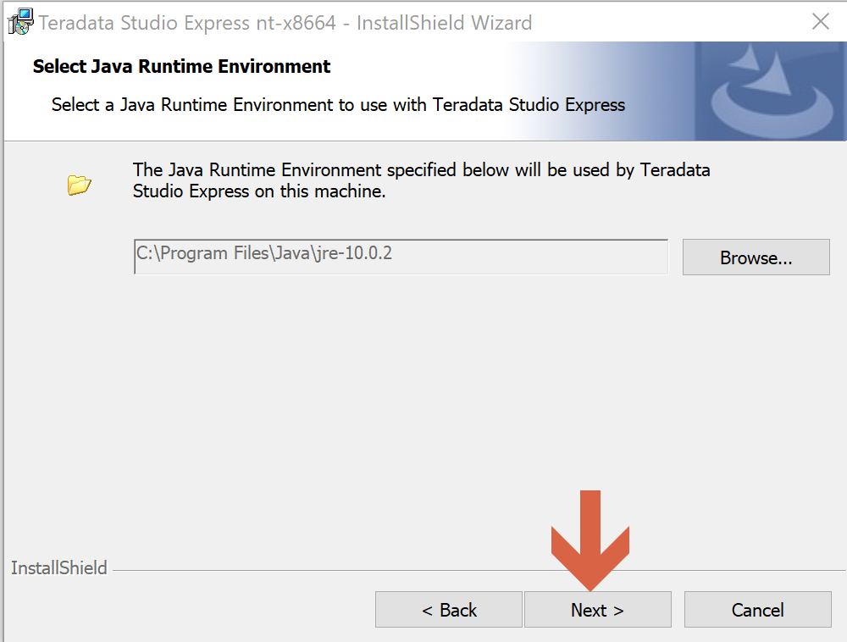

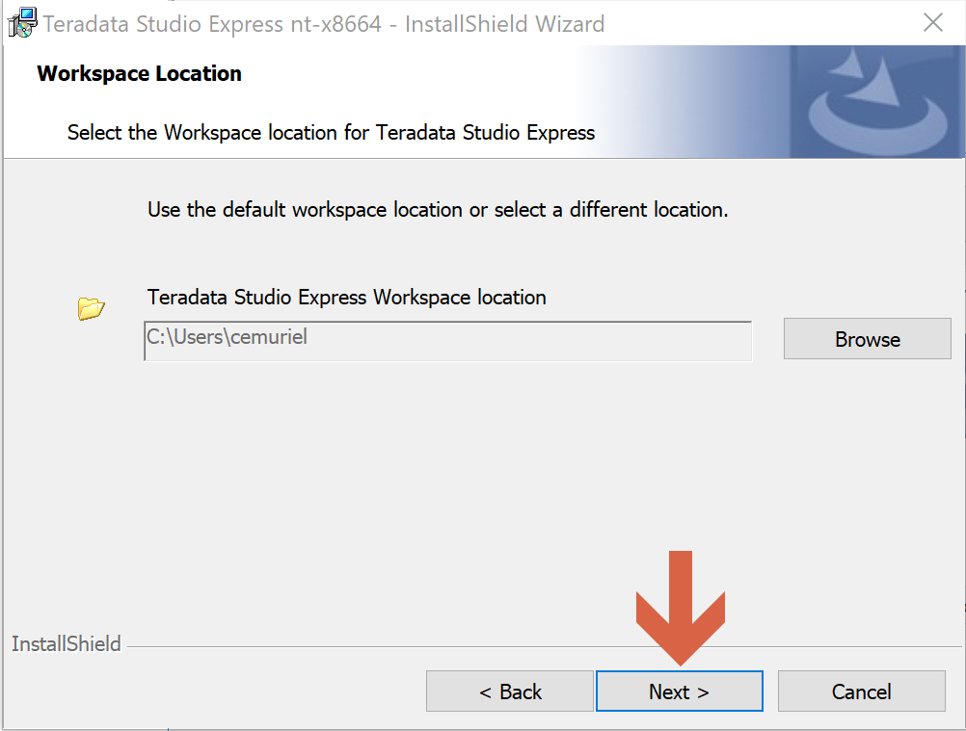

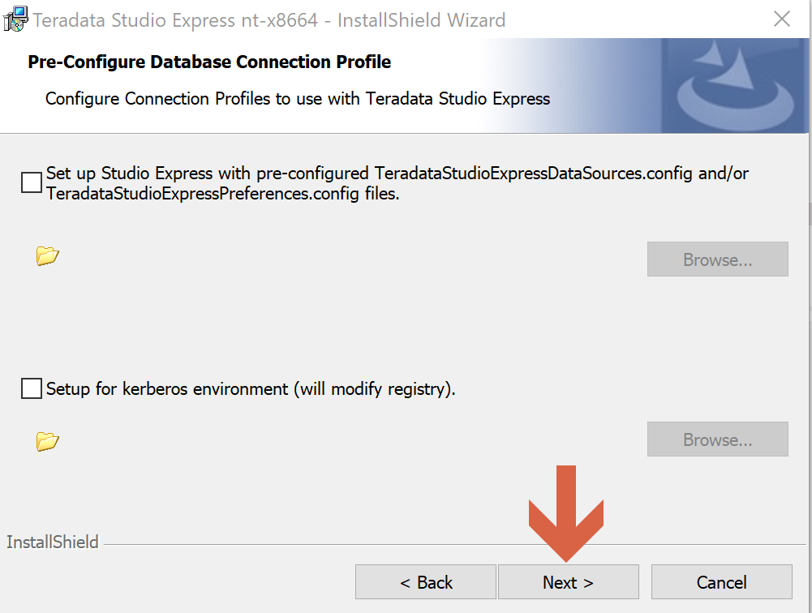

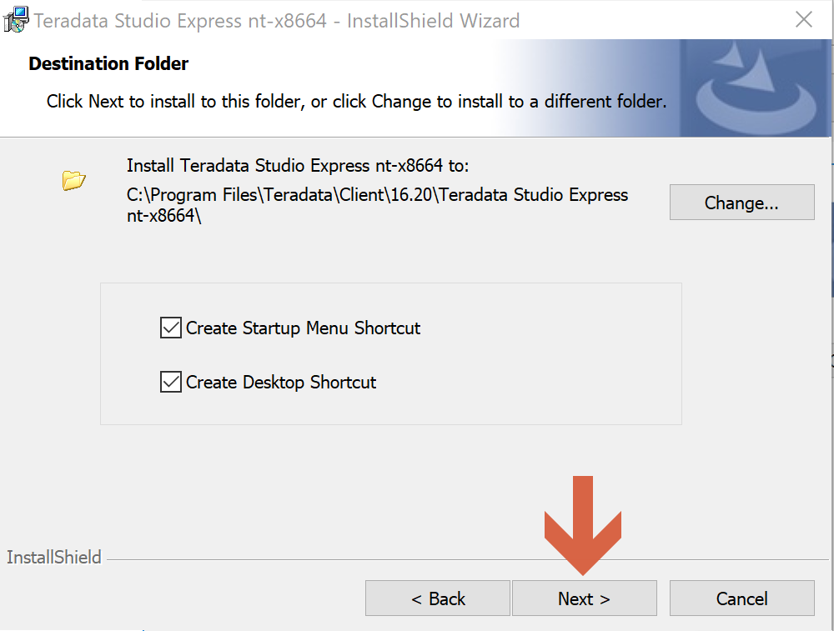

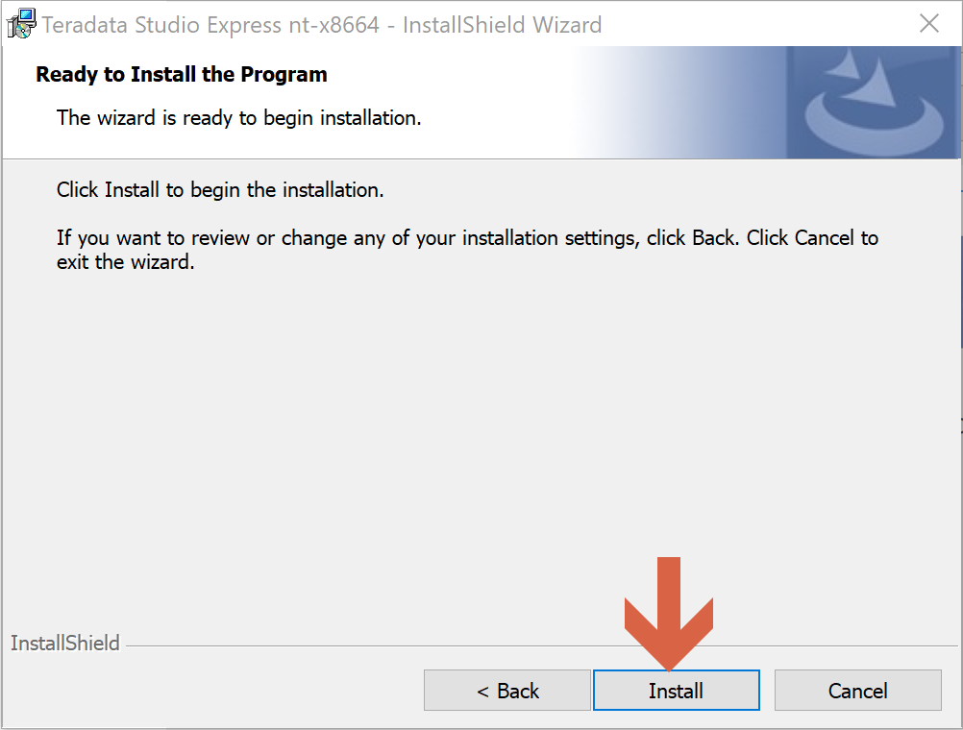

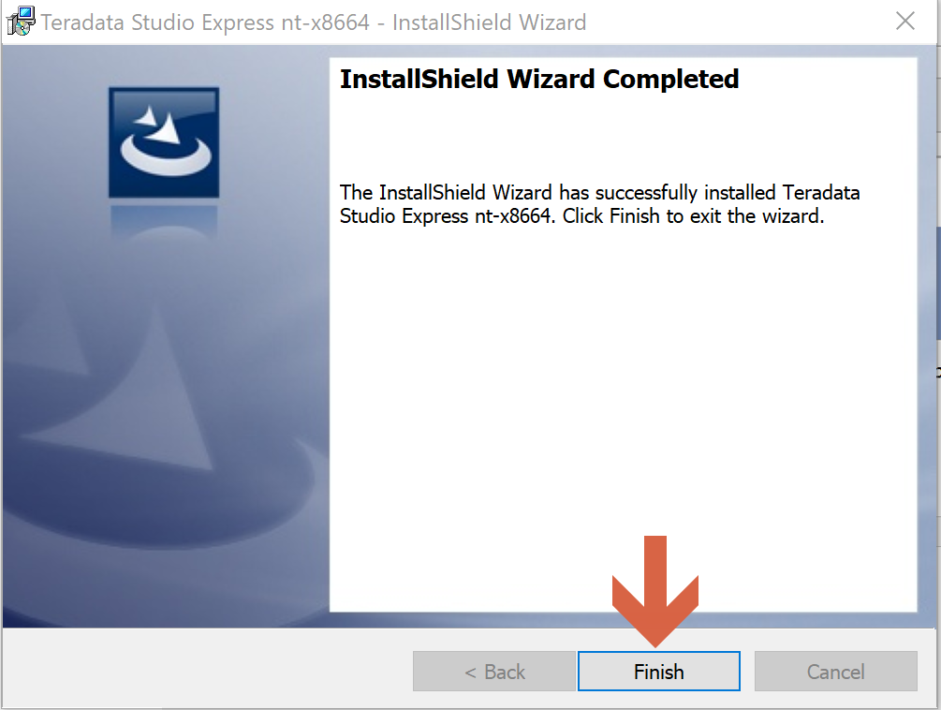

Teradata Studio Express is already installed on our laptop. We can already open it and connect to Teradata Vantage.

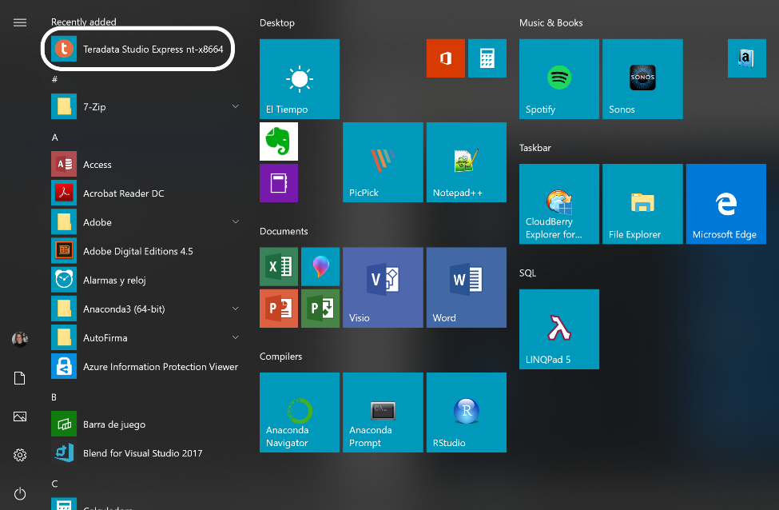

We go to the Teradata Vantage virtual machine in the Azure portal and take note of its IP address and DSN name.

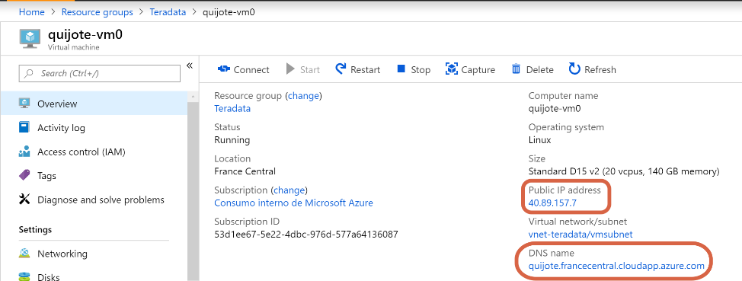

We come back to Teradata Studio Express, right-click on Database Connections, and click on New.

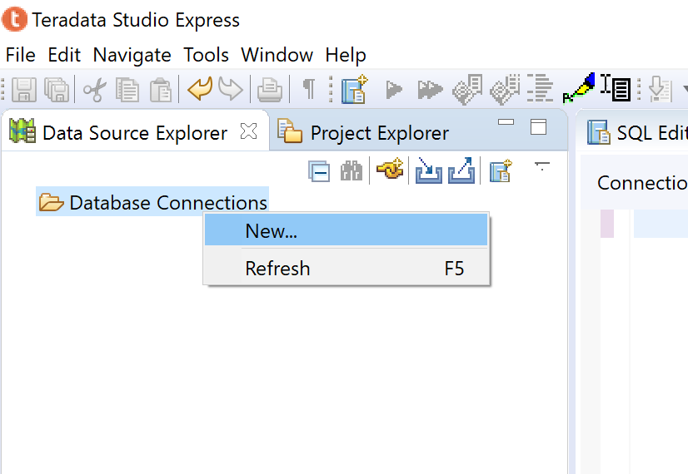

We select a Teradata connection.

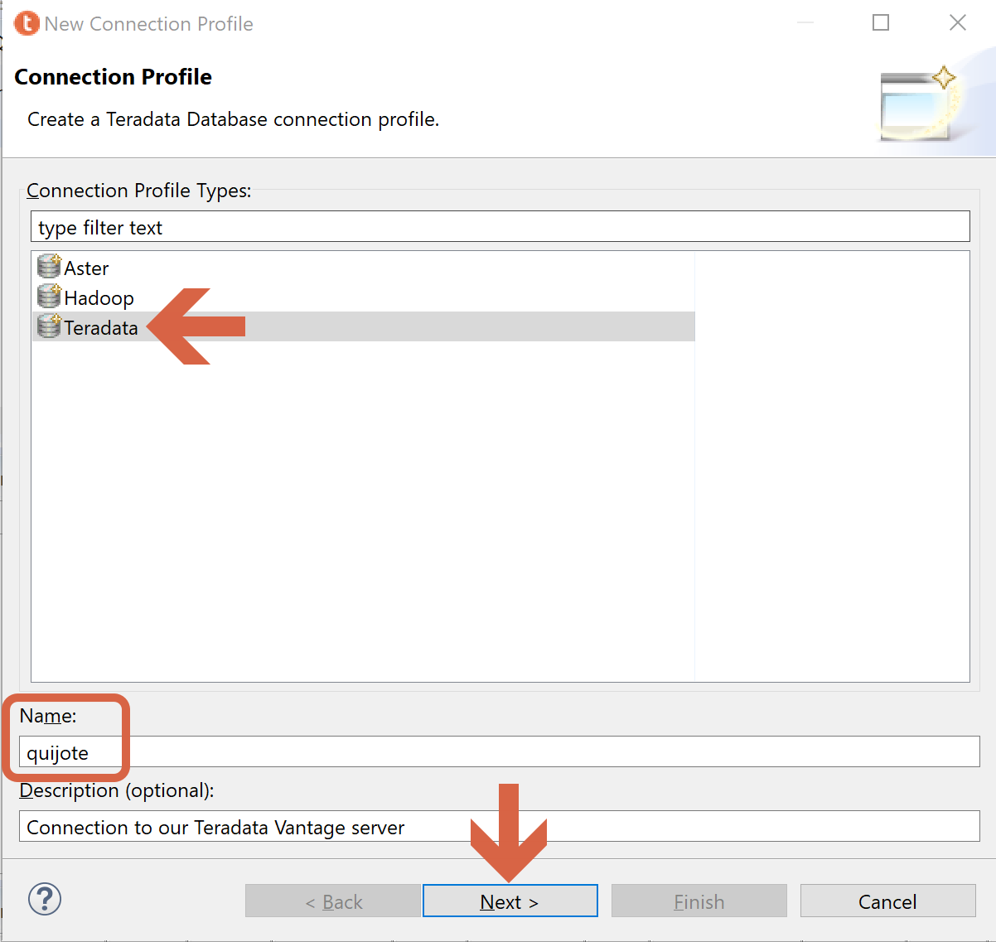

We provide with the information about the public IP address of our Teradata Vantage instance, as well as dbc user and password (we setup dbc password in screen 2, section 2). Then we click on “Test connection” to ping the Teradata virtual machine. If there is no error, we can click on “Finish”.

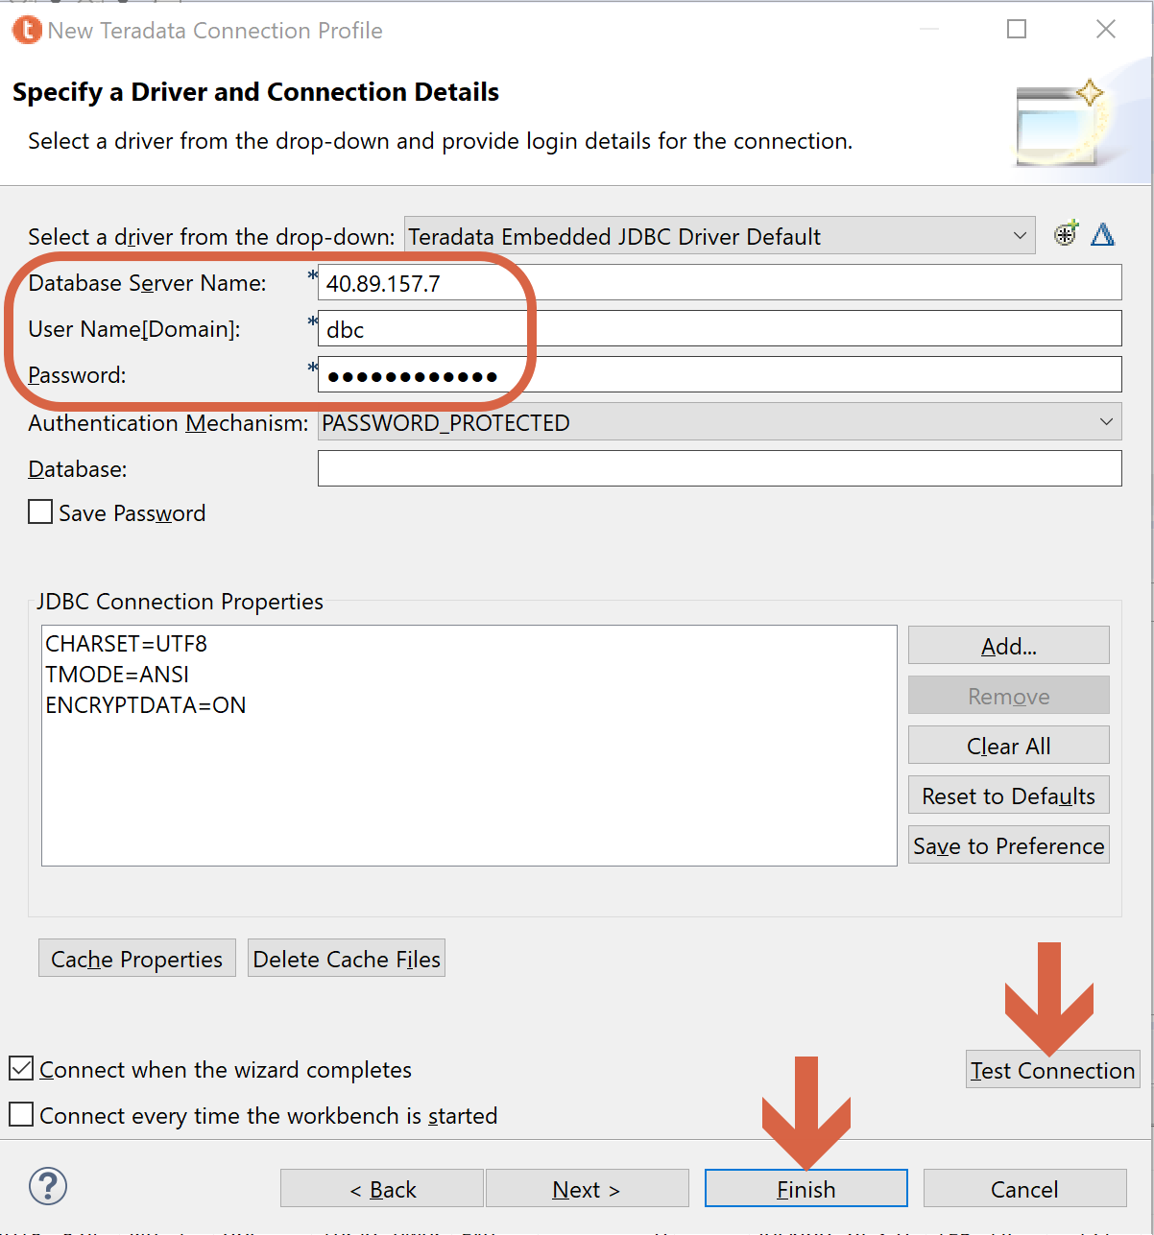

We run a test query to check our connection with Teradata works well.

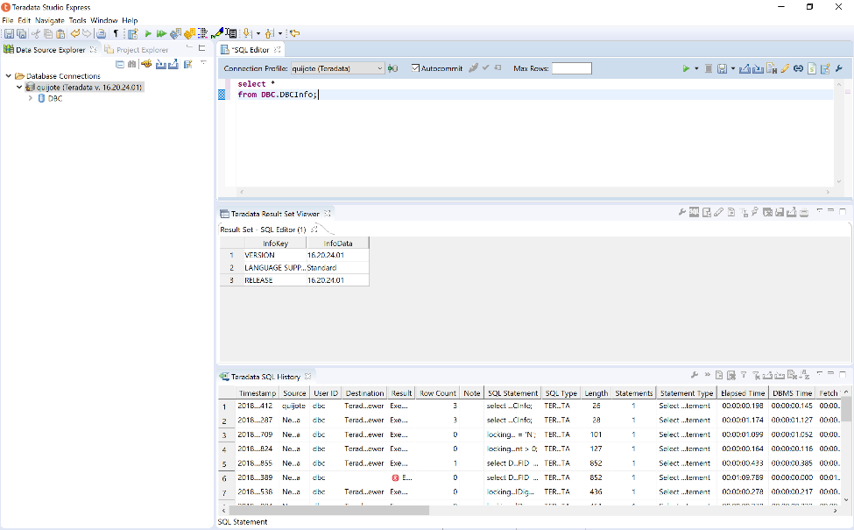

## Connect to Teradata Vantage with other clients – Example BTEQ

If you plan to install Teradata Tools and Utilities (TTU) on a Teradata virtual machine, you cannot install TTU packages on Teradata Vantage virtual machine.

You can install TTU either on an Azure virtual machine running a supported version of Linux or Windows, or on another system running a supported operating system. See [Teradata® Tools and Utilities Supported Platforms and Product Versions](https://docs.teradata.com/viewer/document/Nph5n0VN4FmxOXOLNtp9rg) and [Teradata Tools and Utilities for Microsoft Windows Installation Guide](https://docs.teradata.com/reader/5Z2iFFSaZfr3ZIGLbxnIHg/uHnJbCEzQzRRTOhgr2Wi8g) at [Teradata documentation website](https://docs.teradata.com/).

Obtain the TTU packages from one of the following locations:

1. Teradata customer portal for all supported OS systems
2. Teradata Vantage virtual machine at /var/opt/teradata/TTU_pkgs for Windows OS, Linux or Mac OS X Package

Install and configure the TTU packages according to the instructions in the appropriate installation guide for Teradata Tools and Utilities. The installation guide for Windows is [here](https://docs.teradata.com/reader/5Z2iFFSaZfr3ZIGLbxnIHg/uHnJbCEzQzRRTOhgr2Wi8g).

**As an example, we are going to install BTEQ in Windows in this section.**

At the Azure portal, take note of the public IP address and the DNS name:

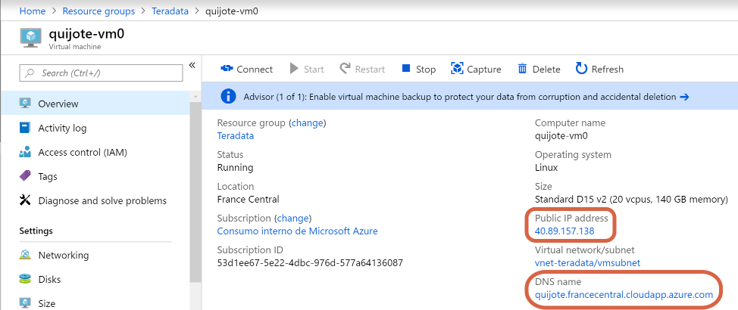

Now we connect to the node operating system. To do it, we are going to use [PuTTY](https://www.putty.org/), which is used to secure remote shell access to a Linux system. If you don’t have PuTTY installed in your computer, you can download it from [here](https://www.putty.org).

We open PuTTY.

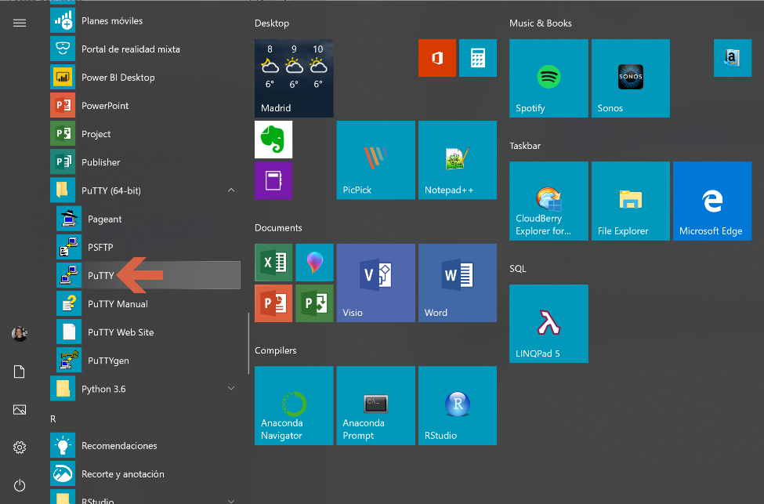

Provide the Teradata node (quijote-vm0) IP address or DNS name, and click “Open”.

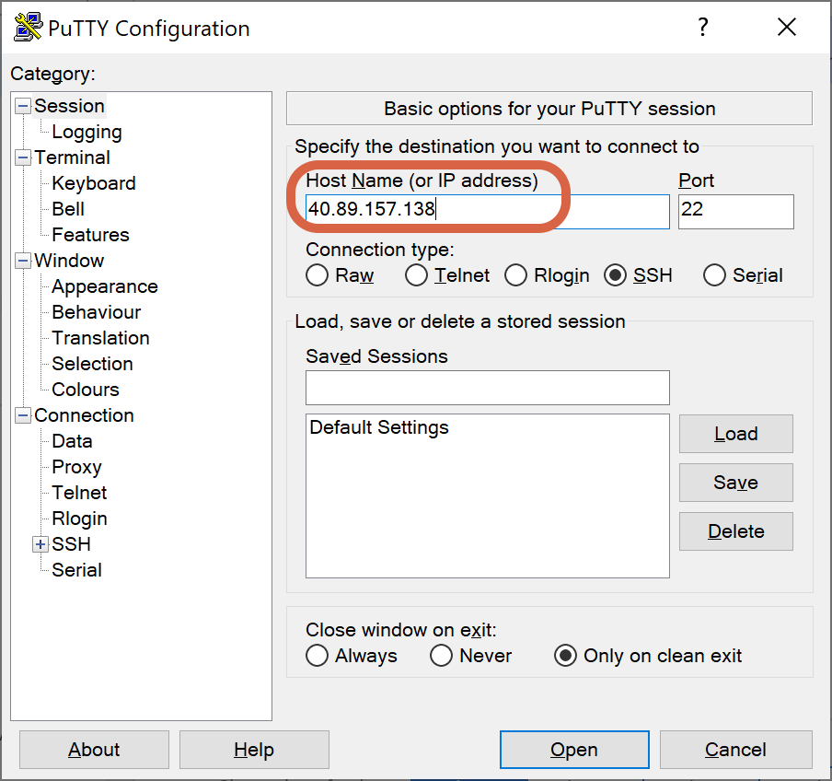

If the PuTTY Security Alert window appears, click on “Yes”.

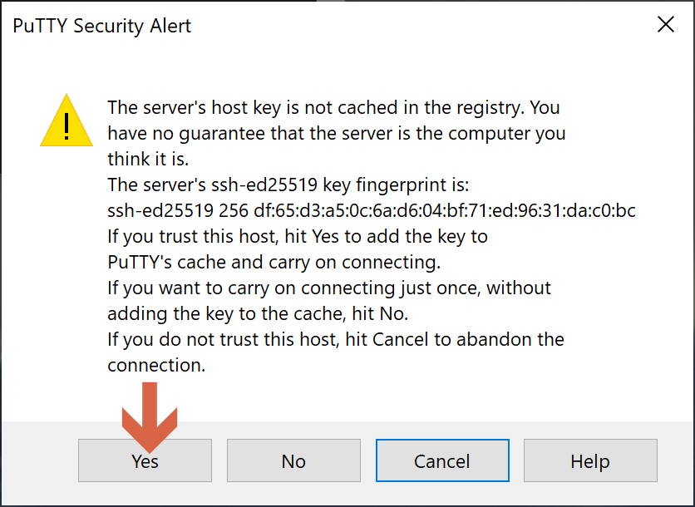

When prompted, provide with the OS user and password which you set up in screen 1, section 2.

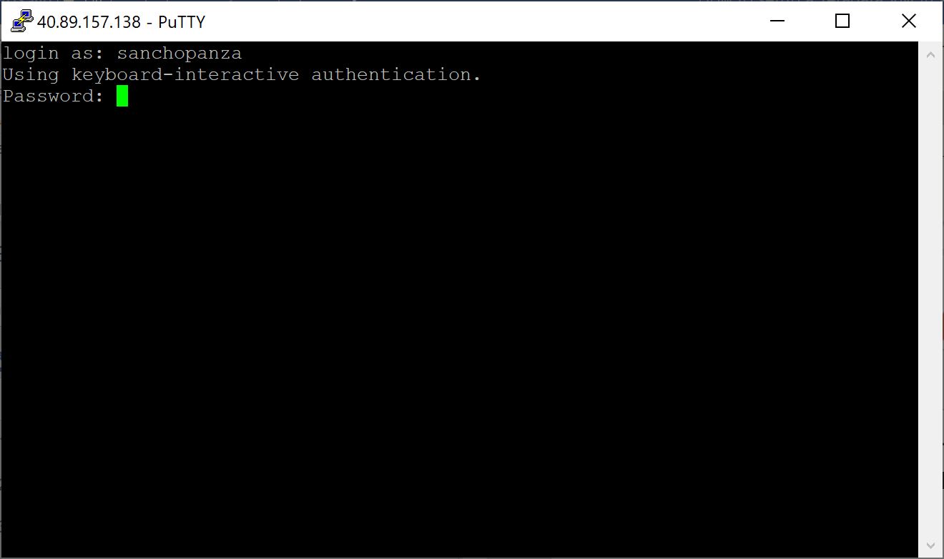

Switch to the root user environment: *sudo su -*

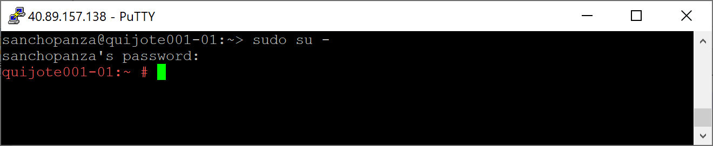

Go to the directory where the TTUs (Teradata clients) are: *cd /var/opt/teradata/*.

We grant permissions to all users to access the TTUs: *chmod 777 TTU_pkgs*

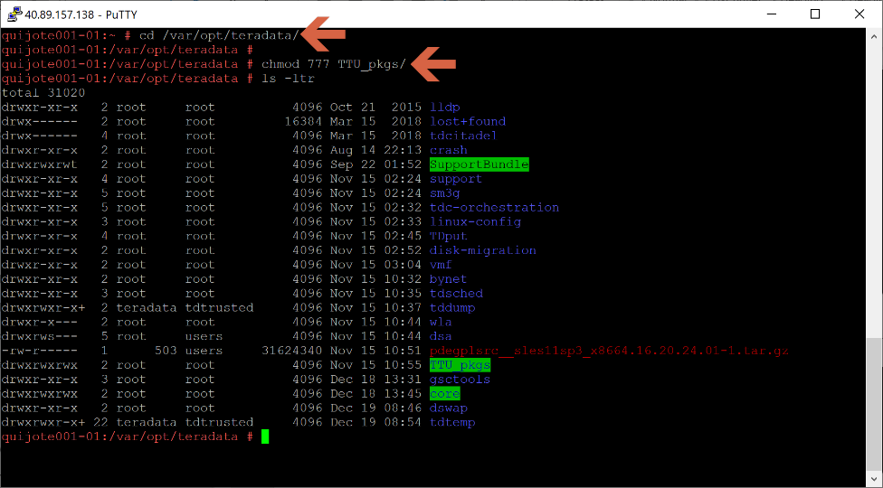

Now we are going to use FileZilla as FTP application to get the TTUs for Windows and download them to our PC. If you need to install it, you can find it [here](https://filezilla-project.org).

Open FileZilla.

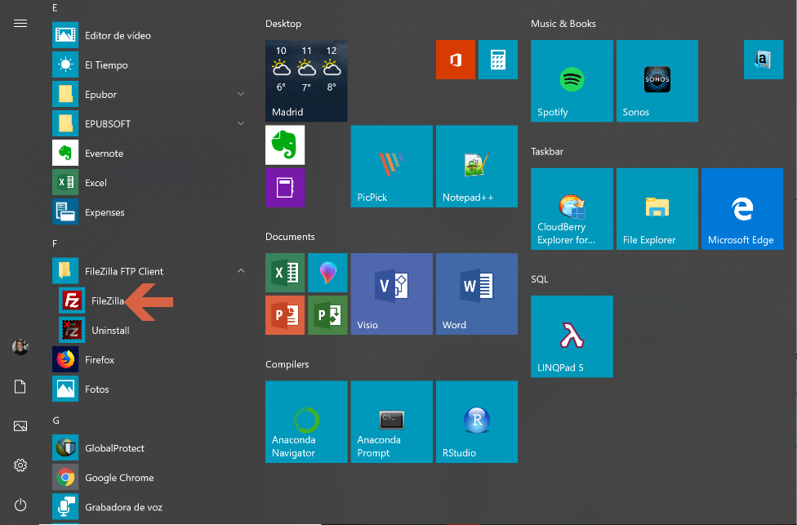

Open the Site Manager in the upper left corner.

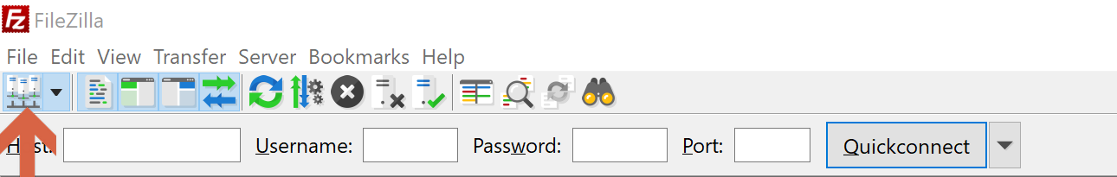

Create a new site to connect with SFT protocol, and provide the Teradata Vantage IP address, and the credentials you created in screen 1, section 2.

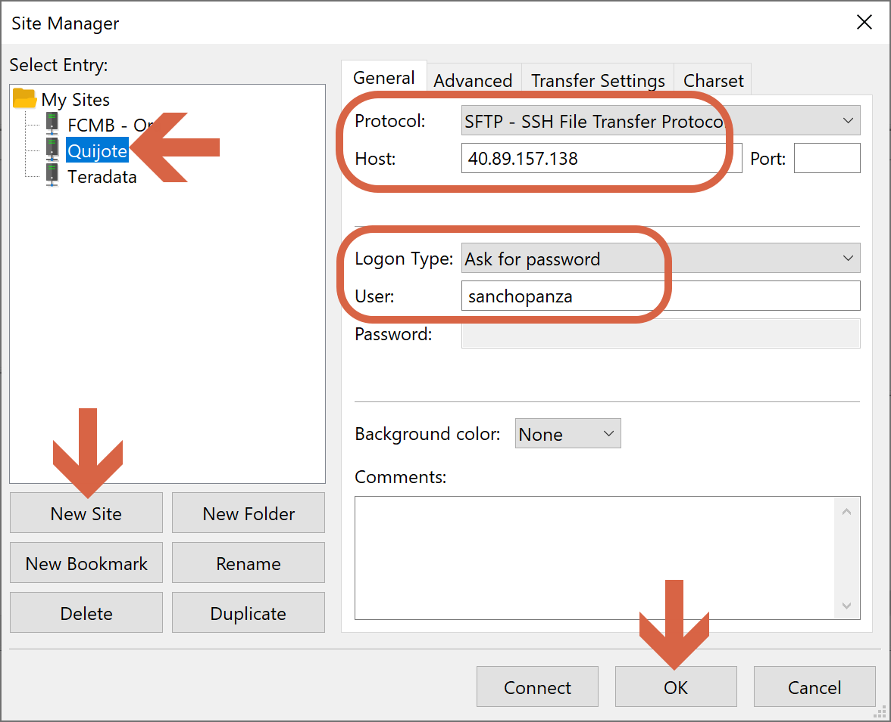

We navigate to the directory in our PC where we want to place the TTUs, and to /var/opt/teradata/TTU_pkgs in the Teradata Vantage node.

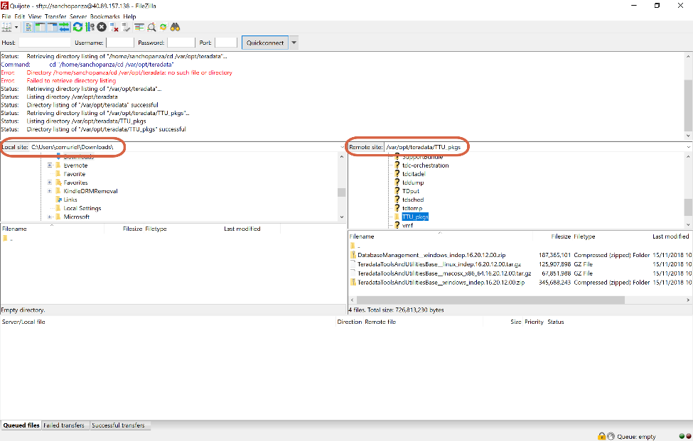

We transfer the ZIP files with the Windows TTUs to our PC.

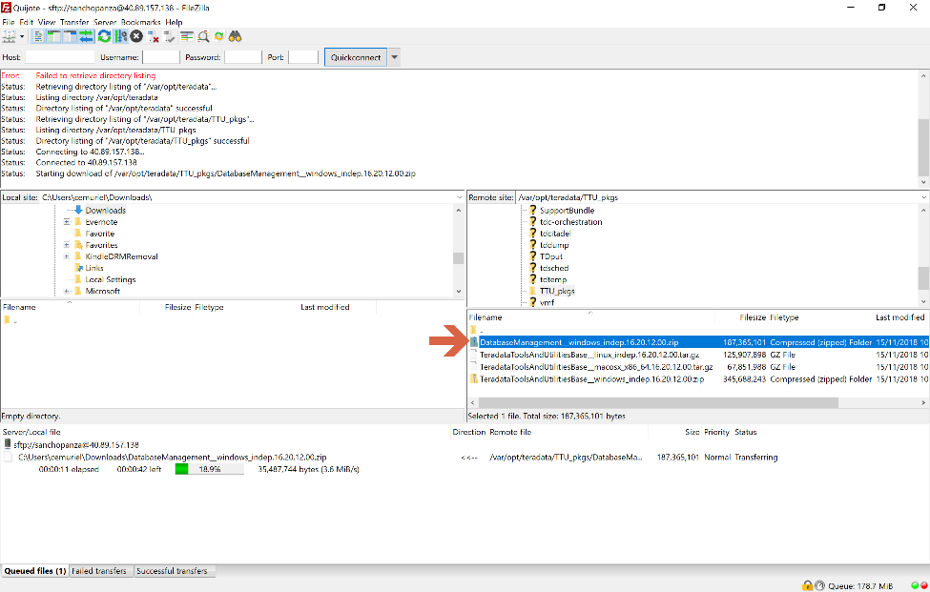

Then, we navigate to the directory in our PC where we downloaded the TTUs. We unzip the file.

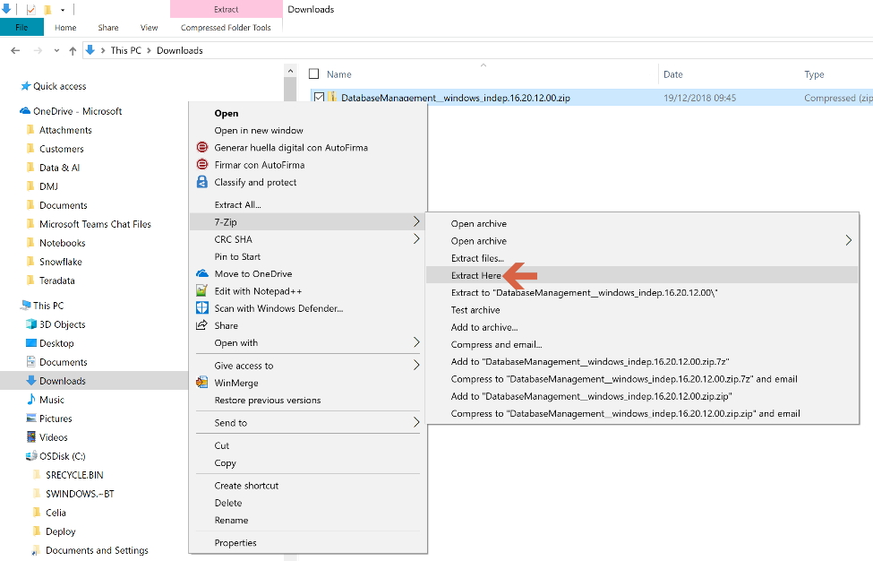

We open the directory “Windows” within the extracted folder, and execute TTU.exe.

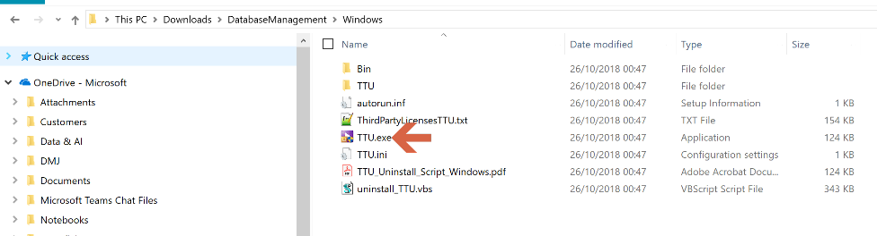

Click “Install Product”.

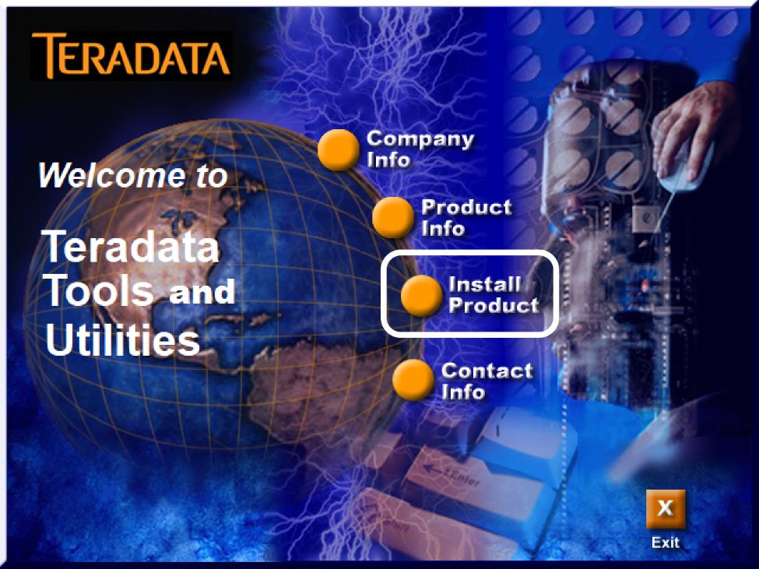

Choose installation language.

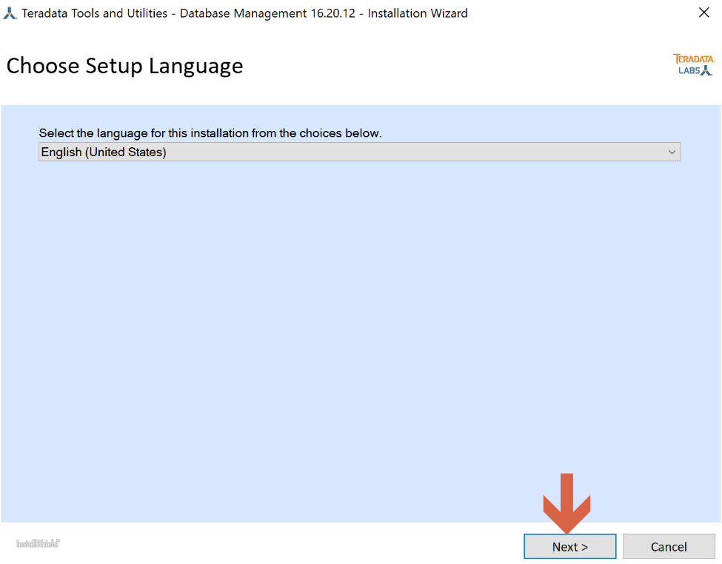

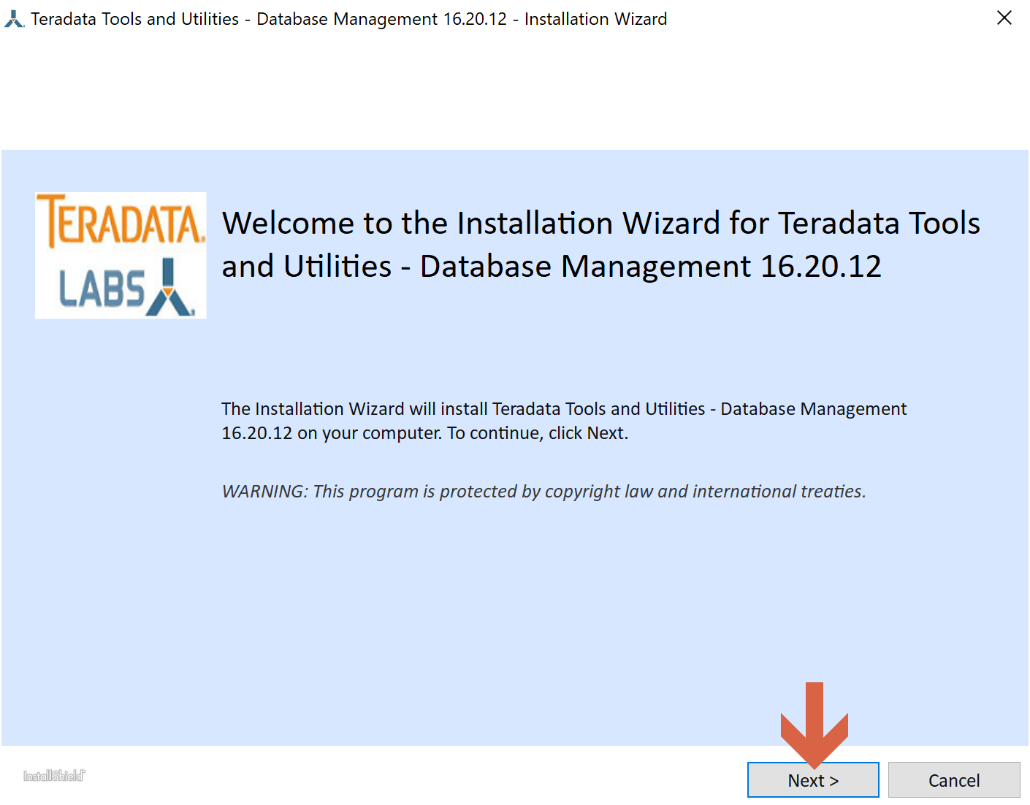

Accept the license agreement.

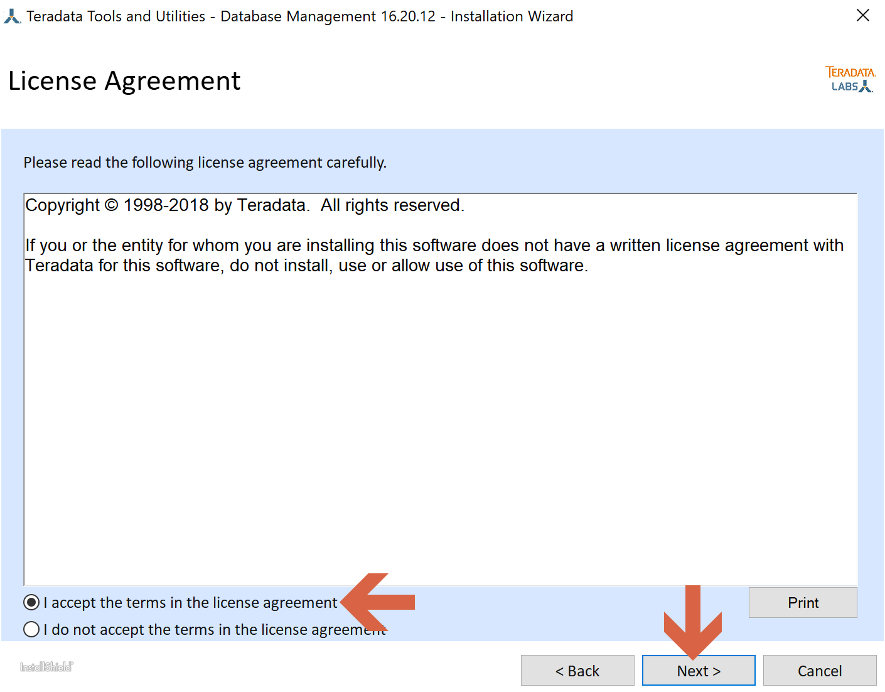

Choose the installation directory.

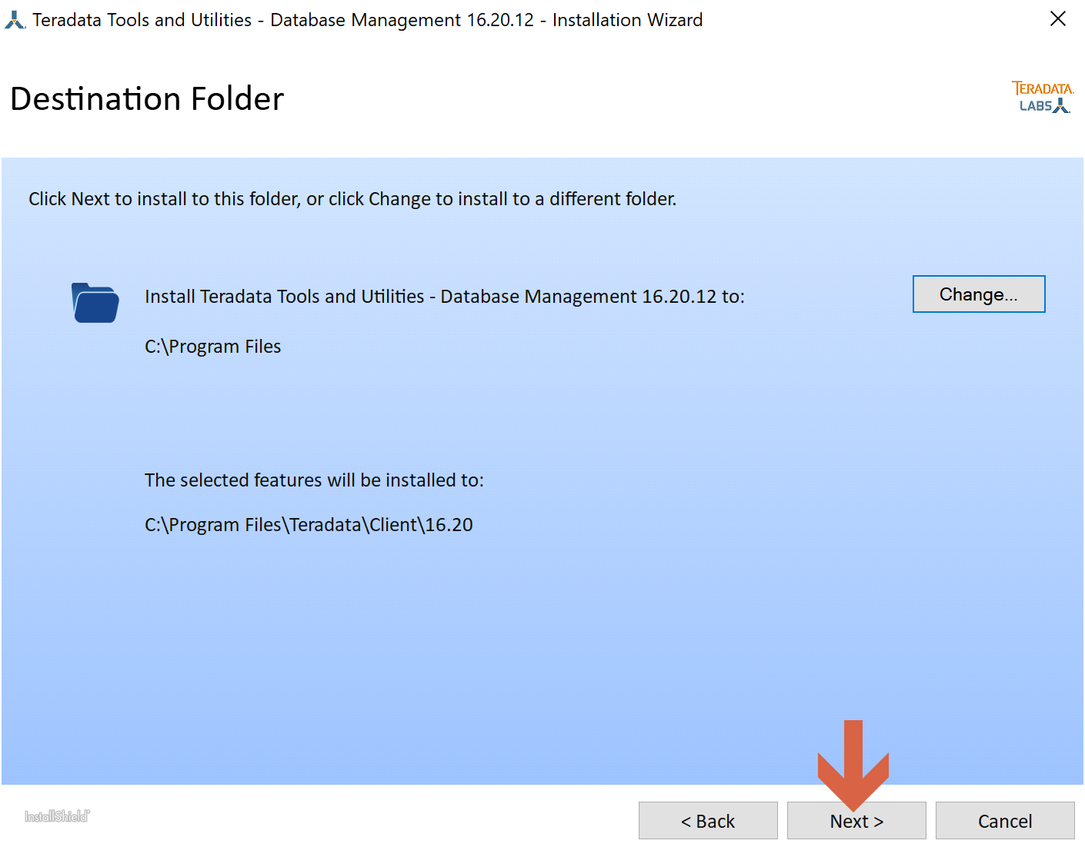

Select the TTU(s) you want to install. We are going to install BTEQ for Windows only.

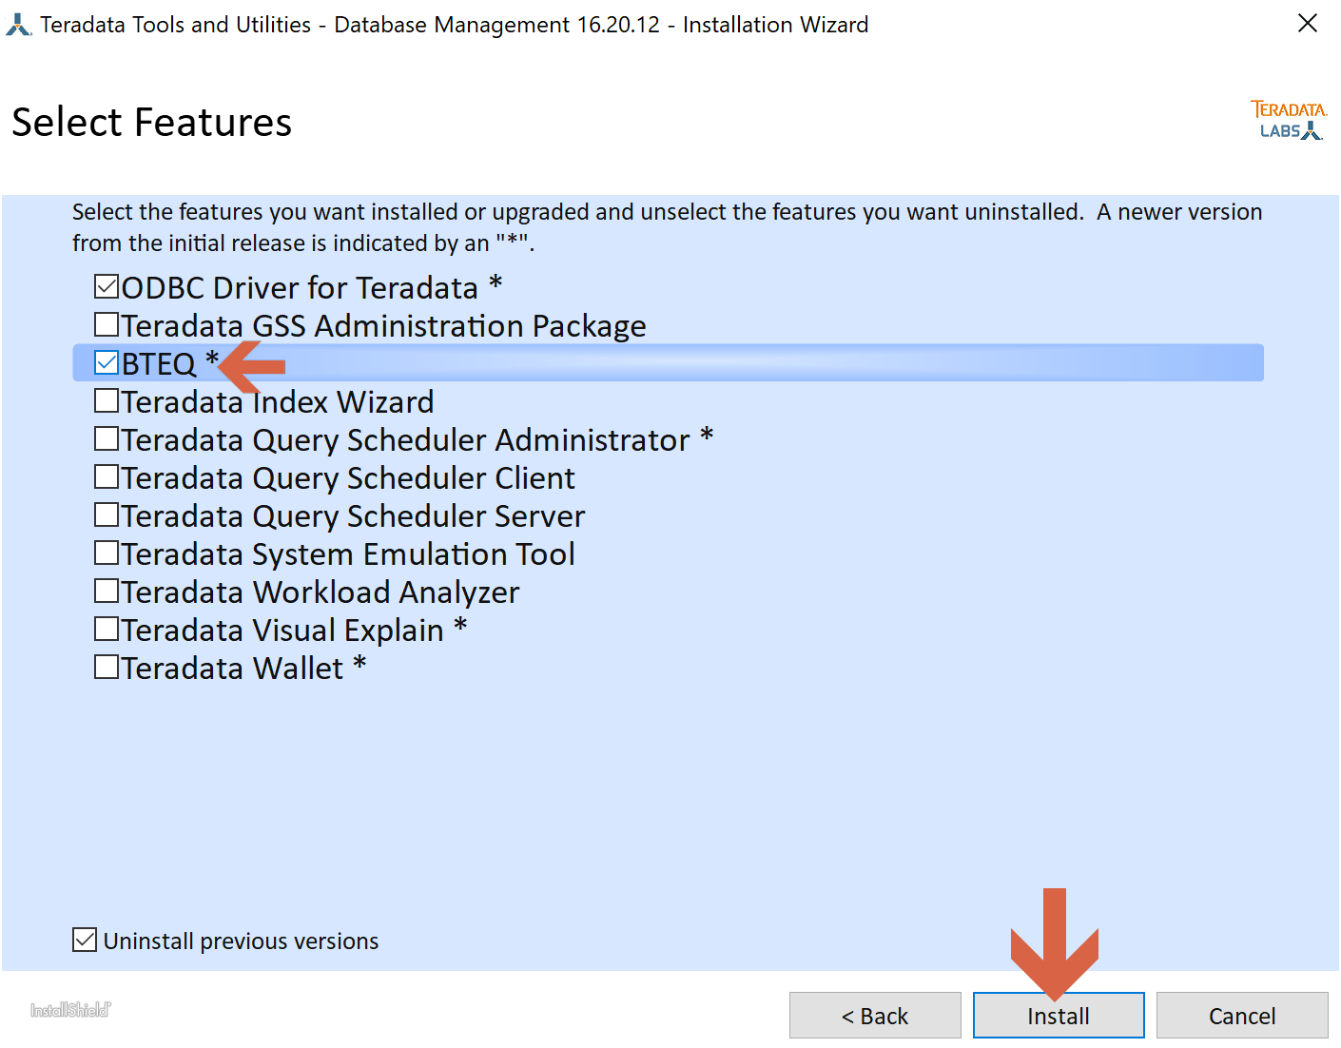

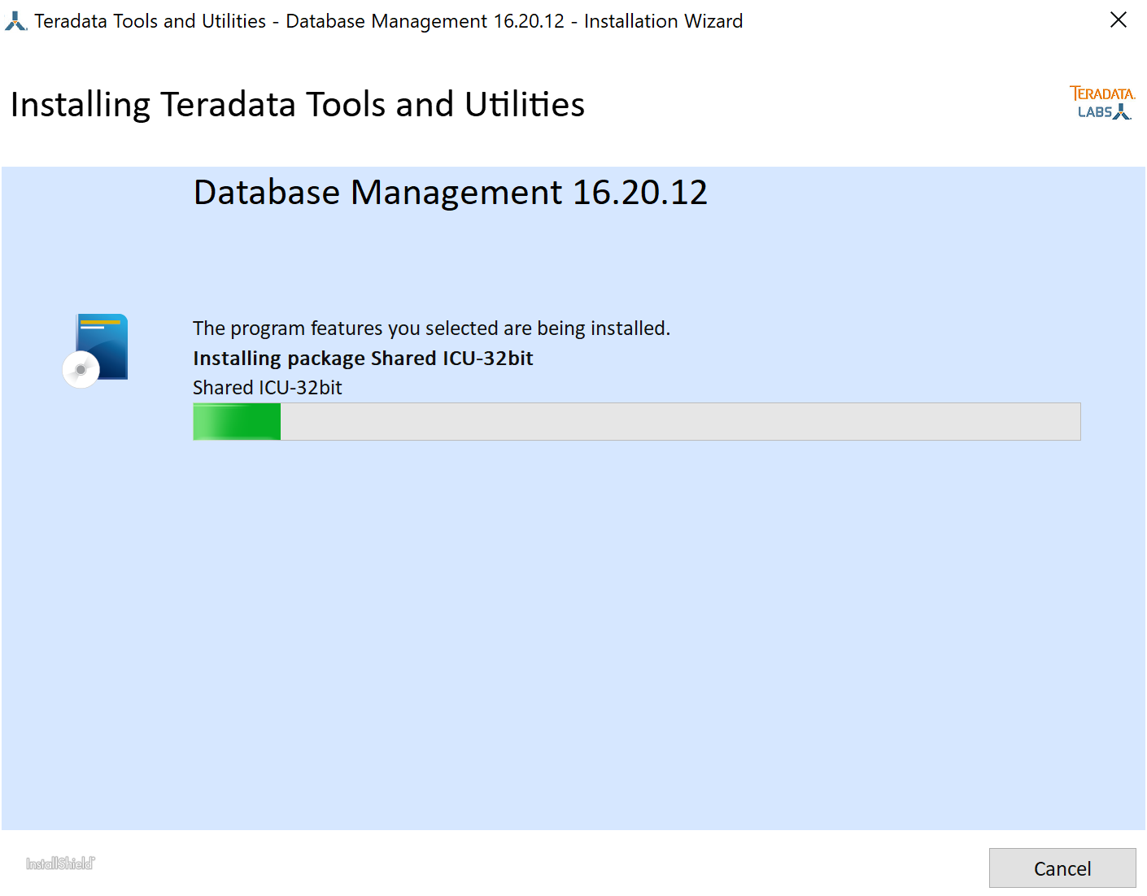

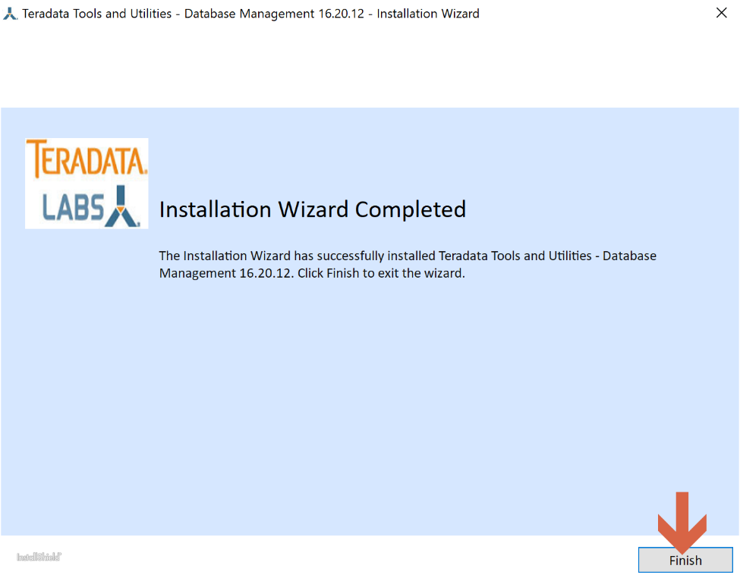

We can open the BTEQ to check it is there.

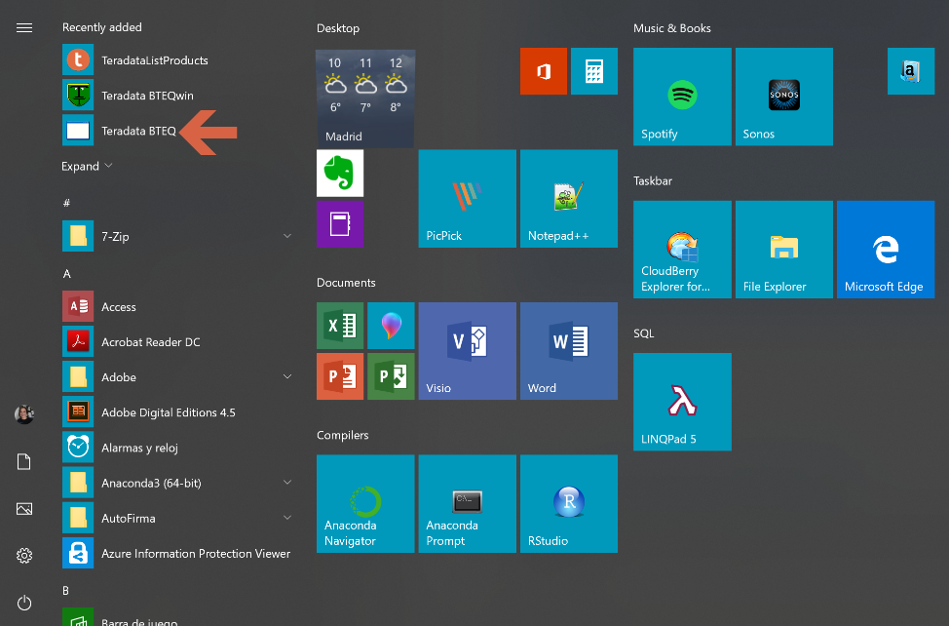

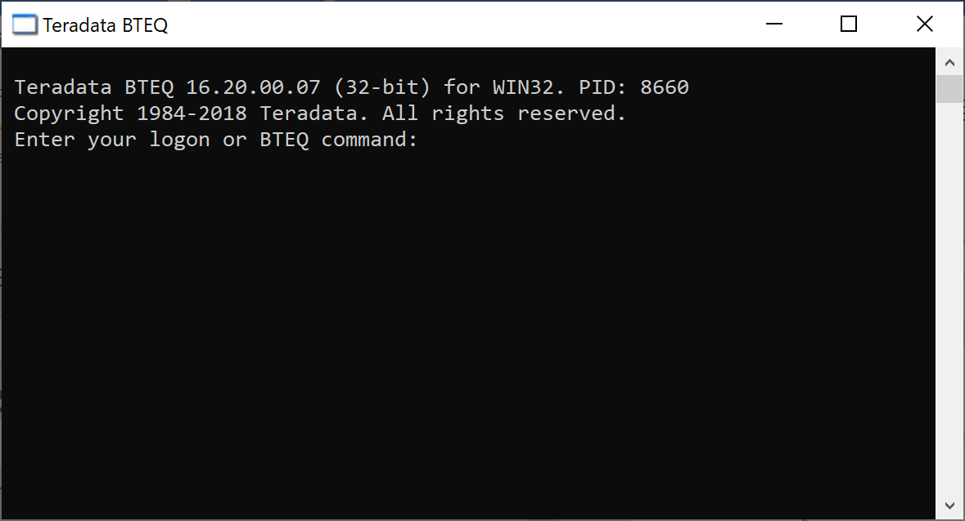

## Connect to Viewpoint

We go to the Viewpoint virtual machine in the Azure portal and take note of its IP address and DSN name.

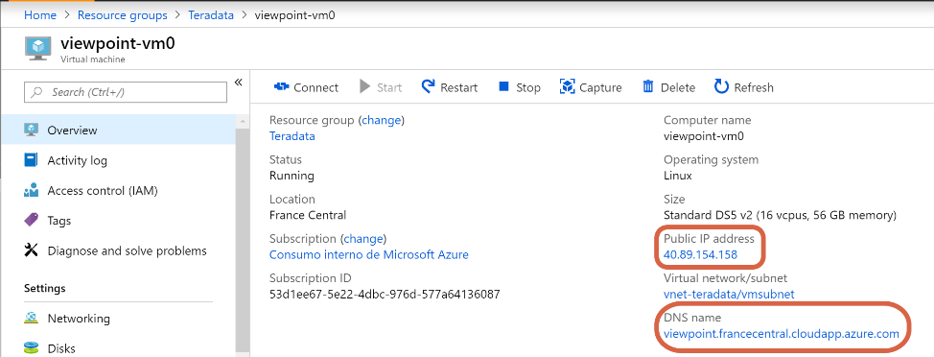

We open a browser and we type in the address bar https://, and then either the IP address or the DNS name. We are going to use the DNS name in this guide.

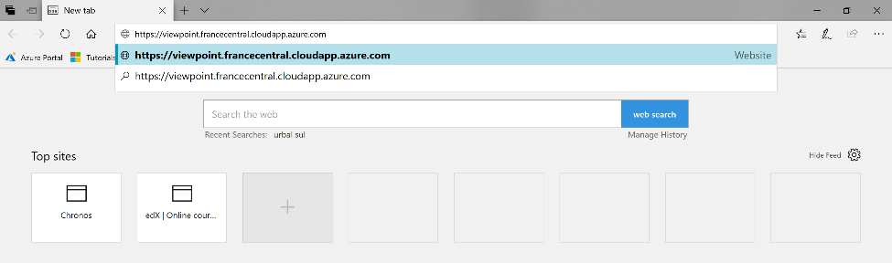

If you are in Microsoft VPN, and get a navigation error like the one below, just continue to the webpage.

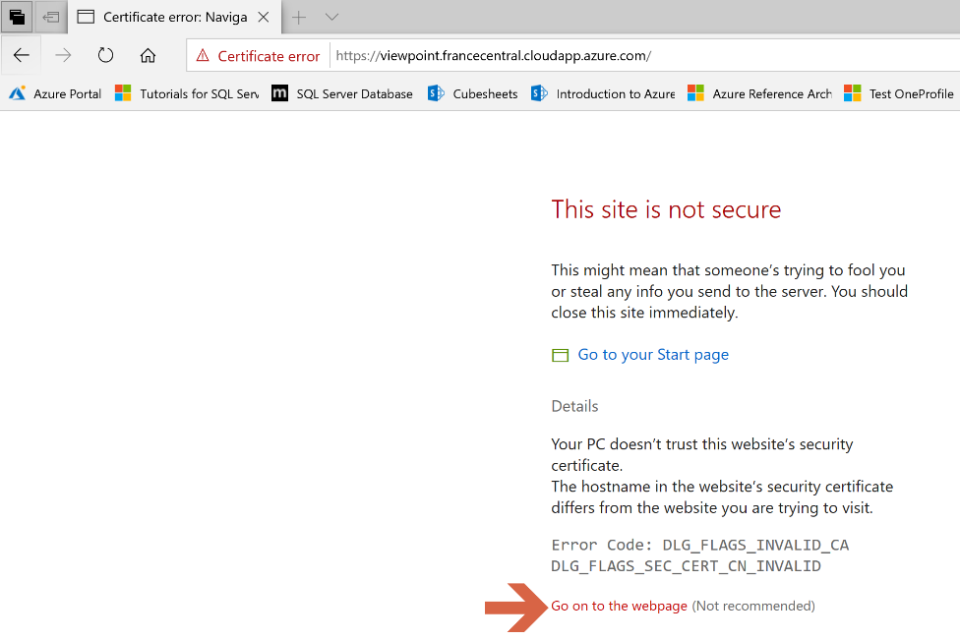

Logon in Viewpoint with the user admin, and the password you setup in screen 3 (Configure Viewpoint), section 2.

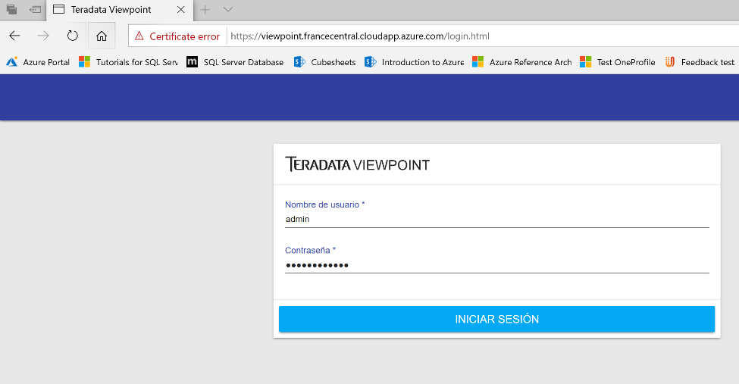

Now you are in.

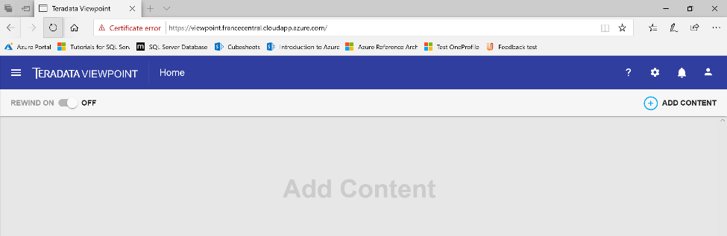

Click on the Admin menu.

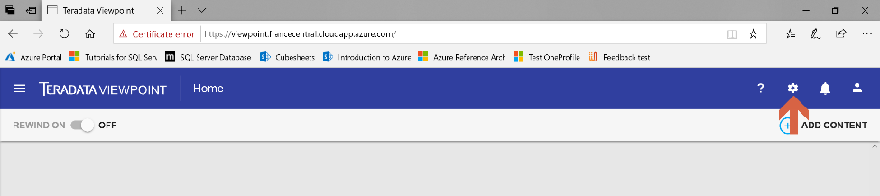

Choose Monitored Systems.

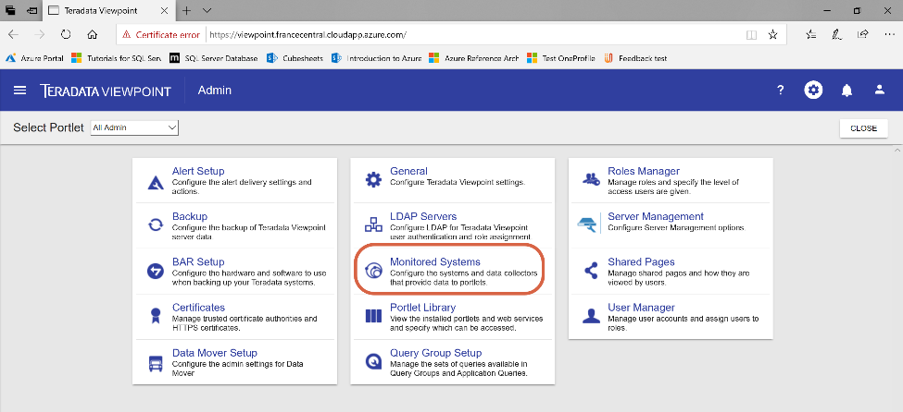

Click on the + symbol.

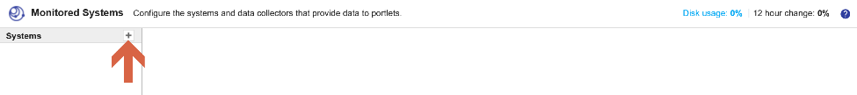

Choose “Add Teradata System”.

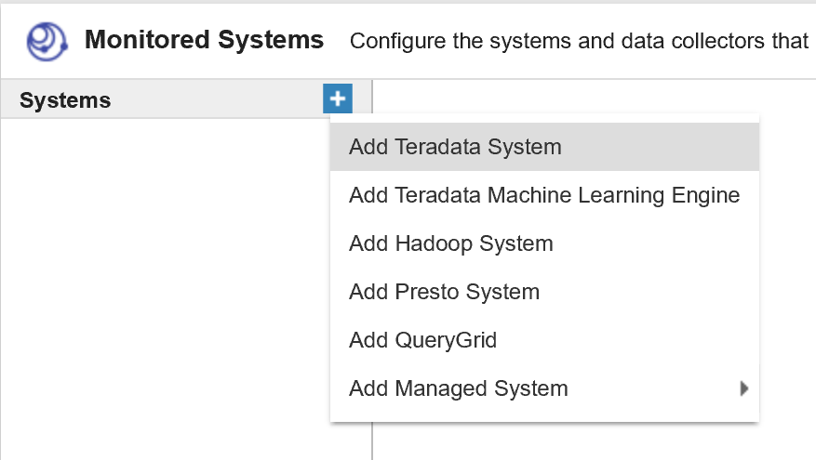

We go to the Teradata Vantage virtual machine in the Azure portal and take note of its IP address and DSN name.



On the Viewpoint portal, we provide with the information to connect to our Teradata instance, including dbc user and password (we setup dbc password in screen 2, section 2). Then we click on “TEST”.

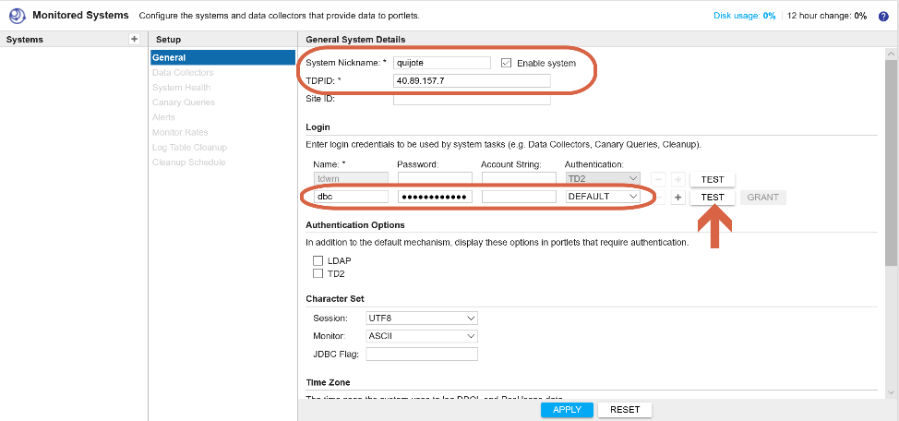

Provide with the information about your time zone.

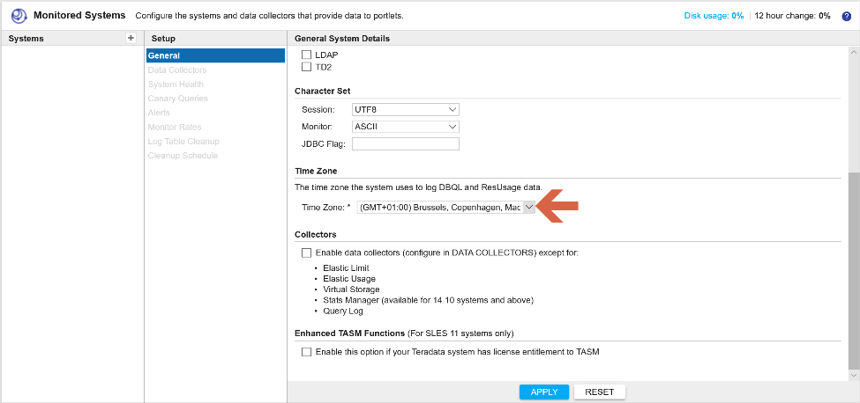

Click on “APPLY”.

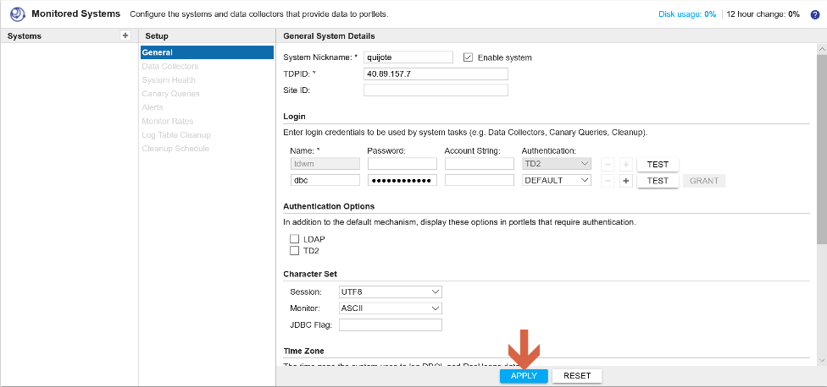

Click “CLOSE” on the upper right corner.

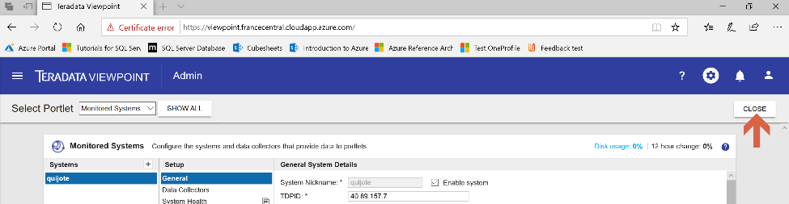

Click on Add Content on the upper right corner, you may choose some portlets to monitor the system you just deployed.

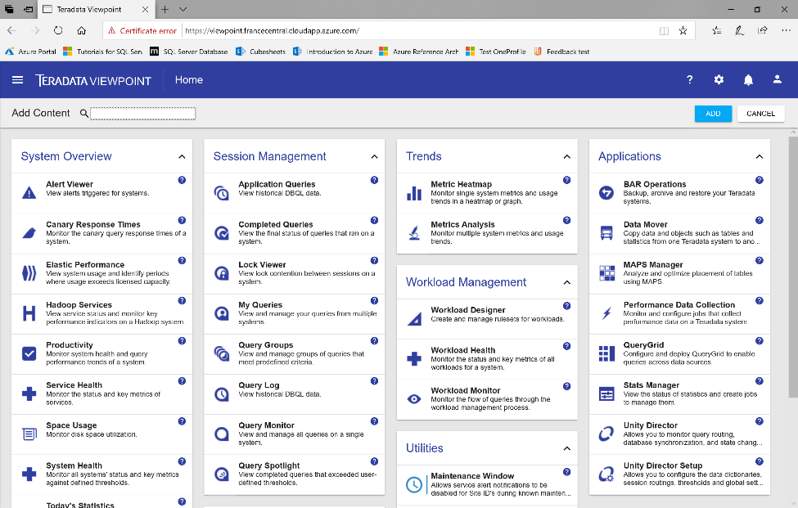

We choose Query Monitor portlet and click the “Add” button.

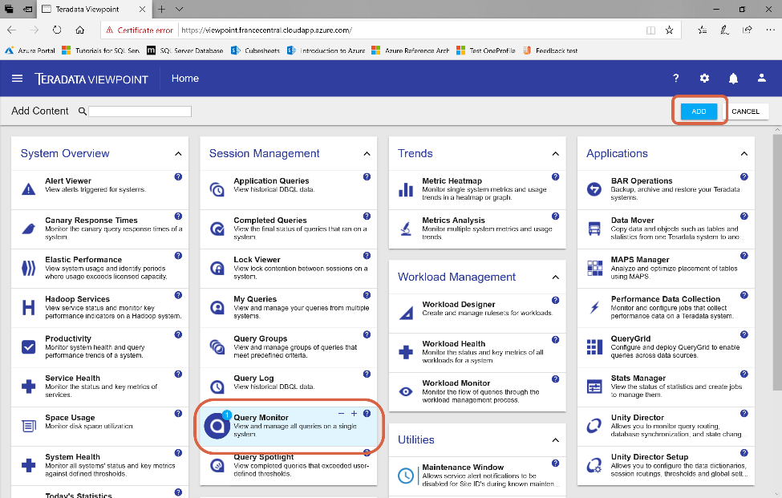

Now you can see the queries which run in Teradata Vantage.

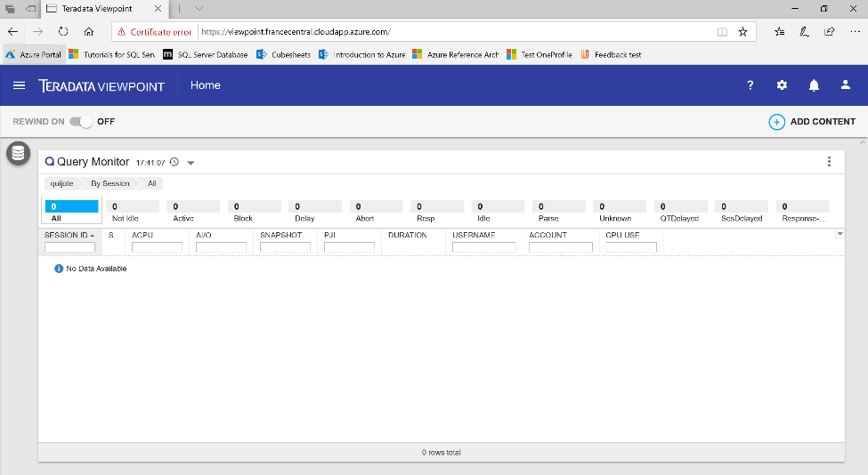

You can start using Viewpoint. If you need further instructions, you can find the manual [here](https://docs.teradata.com/landing-page/).

## Stop and deallocate resources when you don’t use the system

### Teradata Vantage

We go to Teradata Vantage virtual machine in the Azure portal and take note of the IP and DNS name.

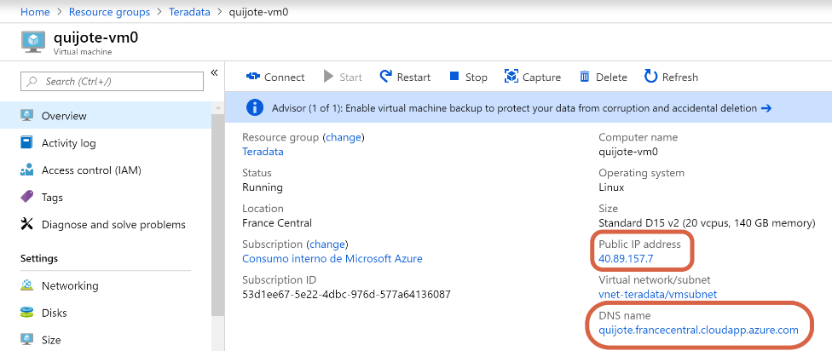

Now we connect to the node operating system. To do it, we are going to use [PuTTY](https://www.putty.org/), which is used to secure remote shell access to a Linux system. If you don’t have PuTTY installed on your computer, you can download it from [here](https://www.putty.org).

We open PuTTY.



Provide the Teradata node (quijote-vm0) IP address or DNS name, and click “Open”.

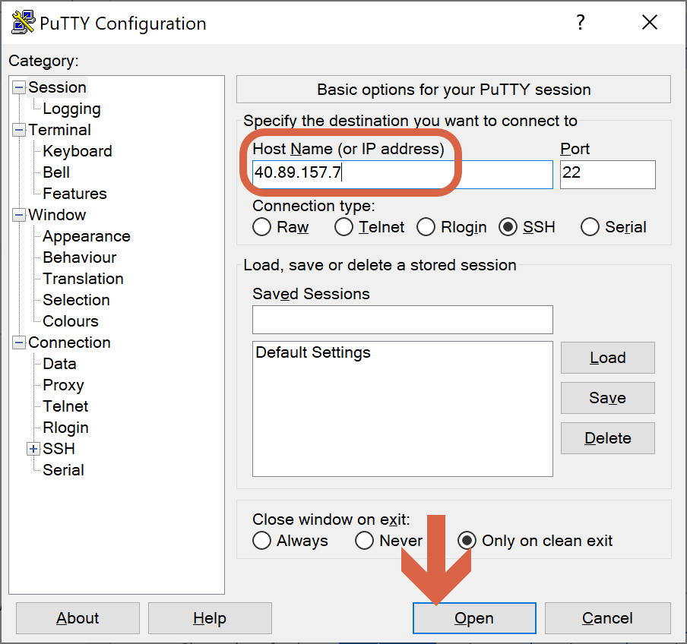

If the PuTTY Security Alert window appears, click on “Yes”.



When prompted, provide with the OS user and password which you setup in screen 1, section 2.

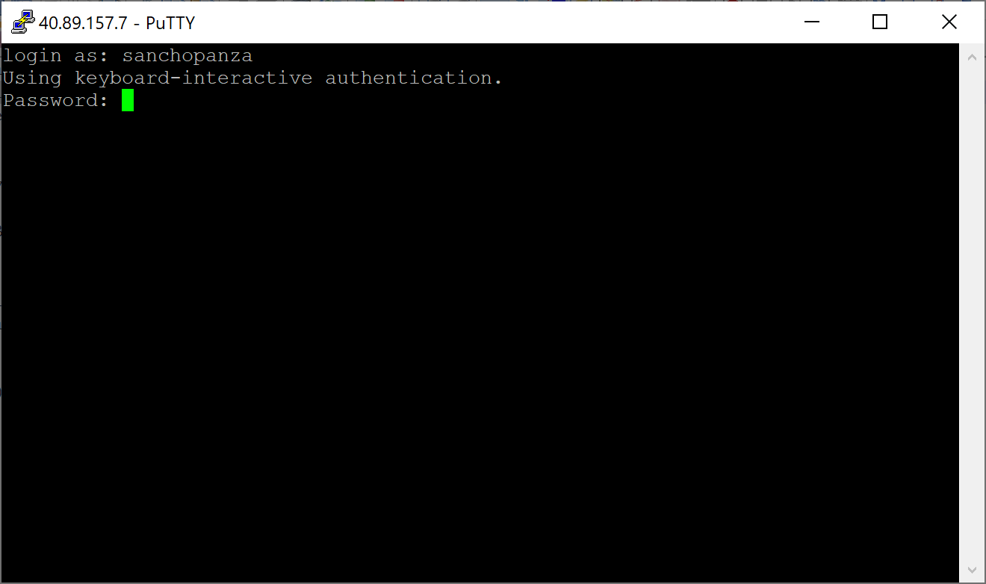

Switch to the root user environment: *sudo su -*

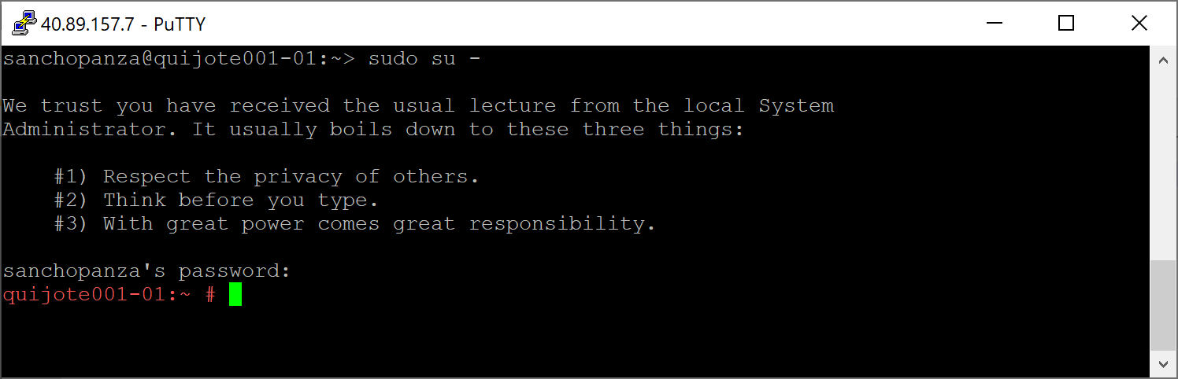

Check the status of the database: *pdestate -a*

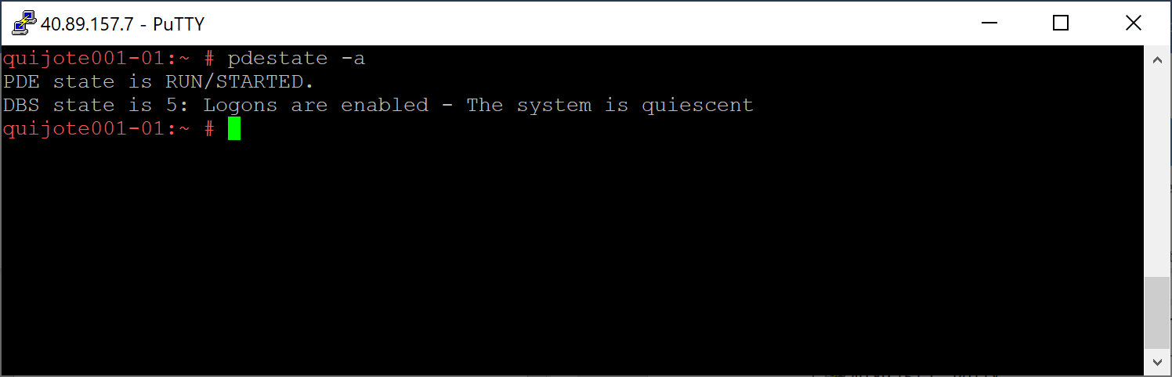

Stop the database: *tpareset -x "Switch Teradata to reduce expenses"*. Putting the database in this state may take several minutes.

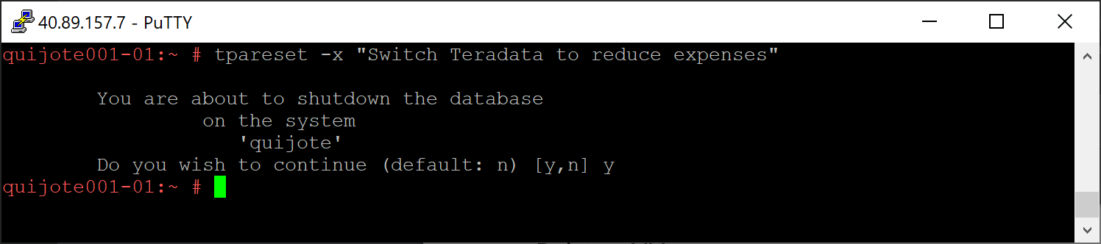

Wait for the database to shut down, and check pdestate is hardstop: *psh pdestate -w*.

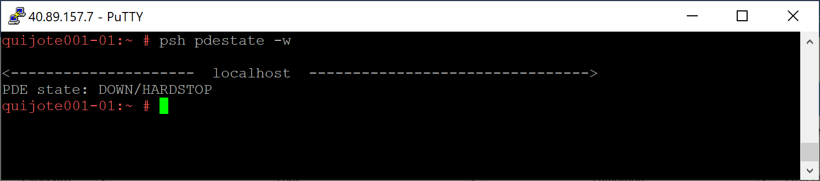

Now you can exit the PuTTY session: *exit*.

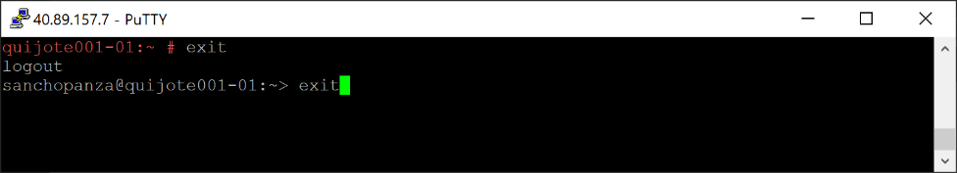

From the Azure portal, stop the virtual machines associated with Teradata Vantage.

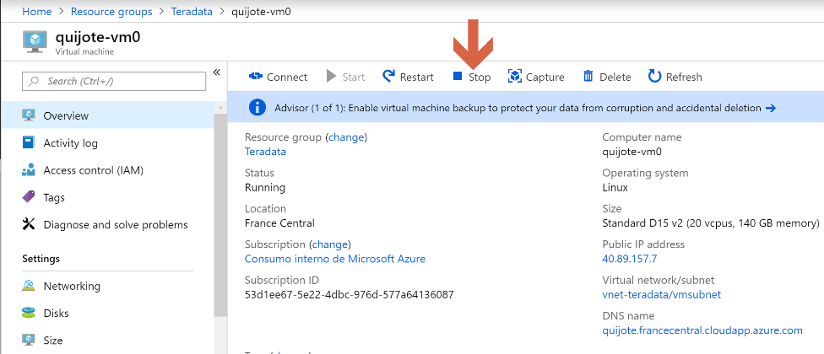

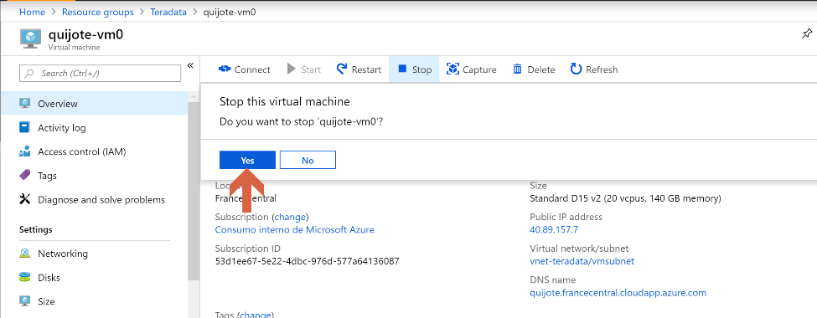

### Viewpoint

We go to Viewpoint virtual machine in the Azure portal and take note of the IP and DNS name.

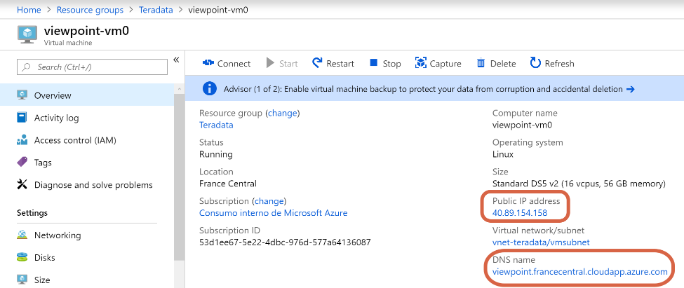

Now we connect to the node operating system. To do it, we are going to use [PuTTY](https://www.putty.org/), which is used to secure remote shell access to a Linux system. If you don’t have PuTTY installed in your computer, you can download it from [here](https://www.putty.org).

We open PuTTY.



Provide the Viewpoint node (viewpoint-vm0) IP address or DNS name, and click “Open”.

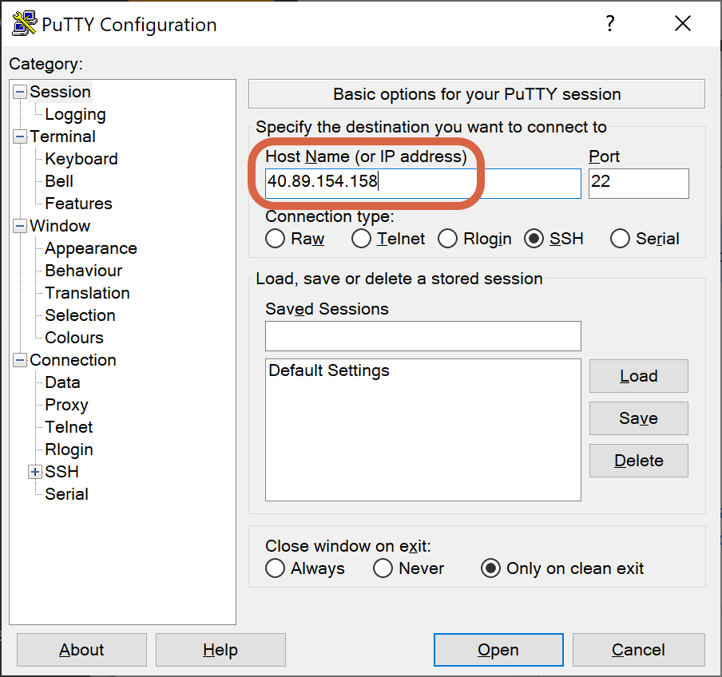

If the PuTTY Security Alert window appears, click on “Yes”.



When prompted, provide with the OS user and password which you setup in screen 1, section 2.

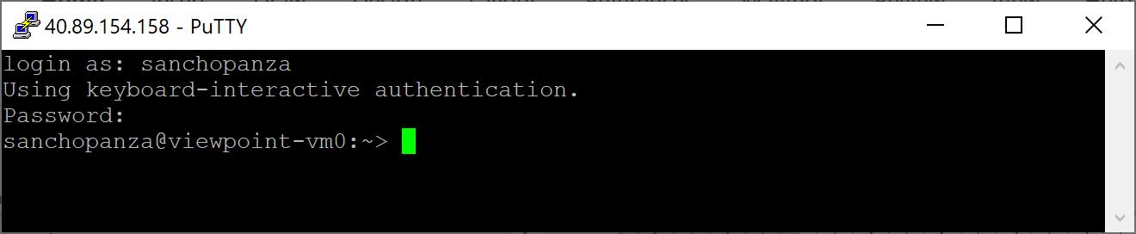

Switch to the root user environment: *sudo su -*

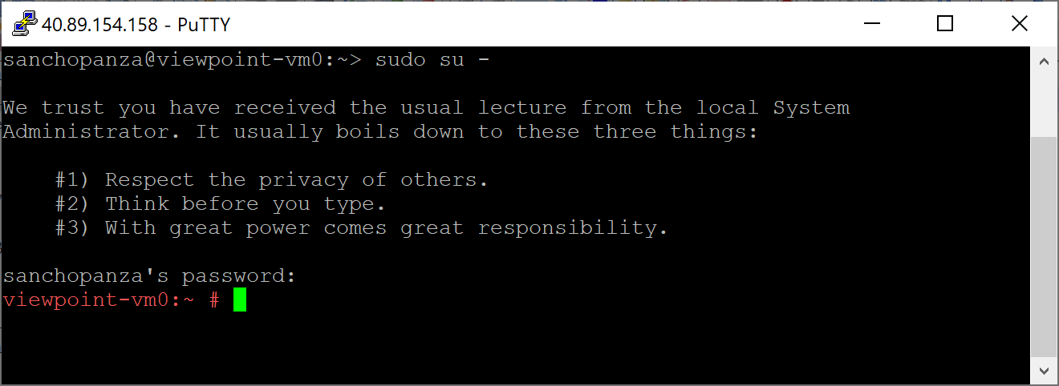

Check the status of the Viewpoint services: */opt/teradata/viewpoint/bin/vp-control.sh status*

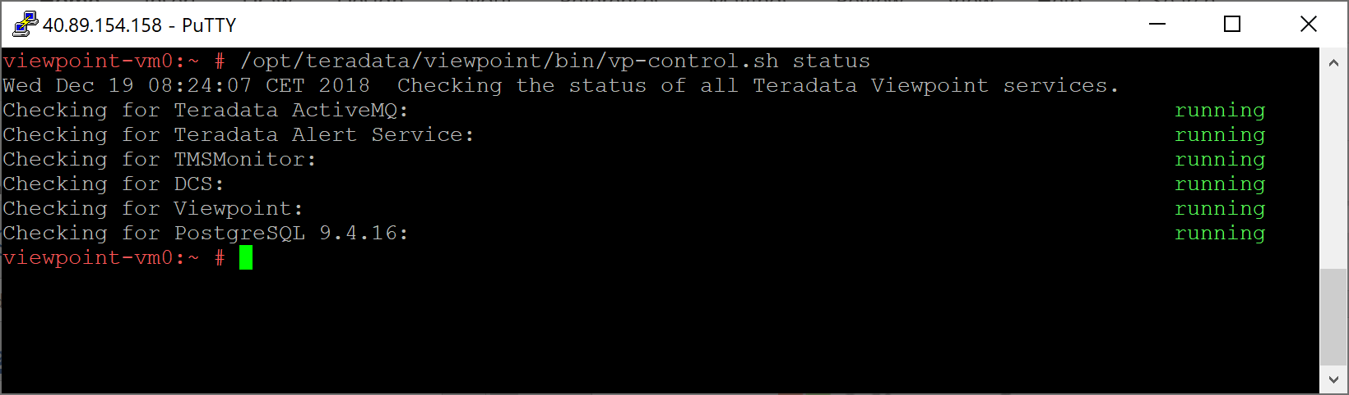

Shut down all Viewpoint services: */opt/teradata/viewpoint/bin/vp-control.sh stop*. Putting the database in this state may take several minutes.

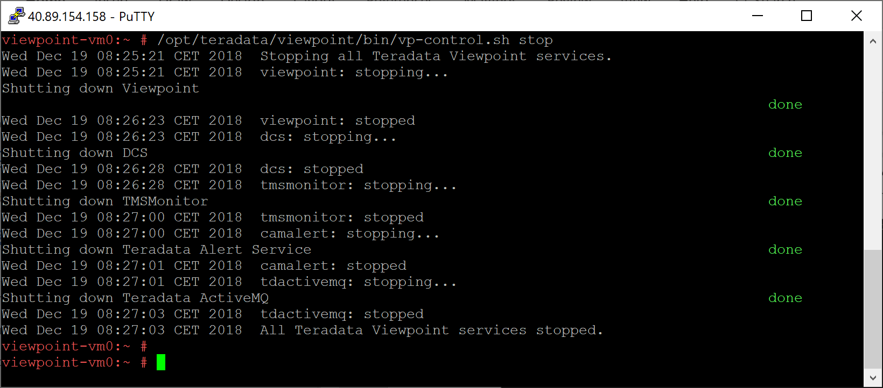

You can check the Viewpoint services are down: */opt/teradata/viewpoint/bin/vp-control.sh status*

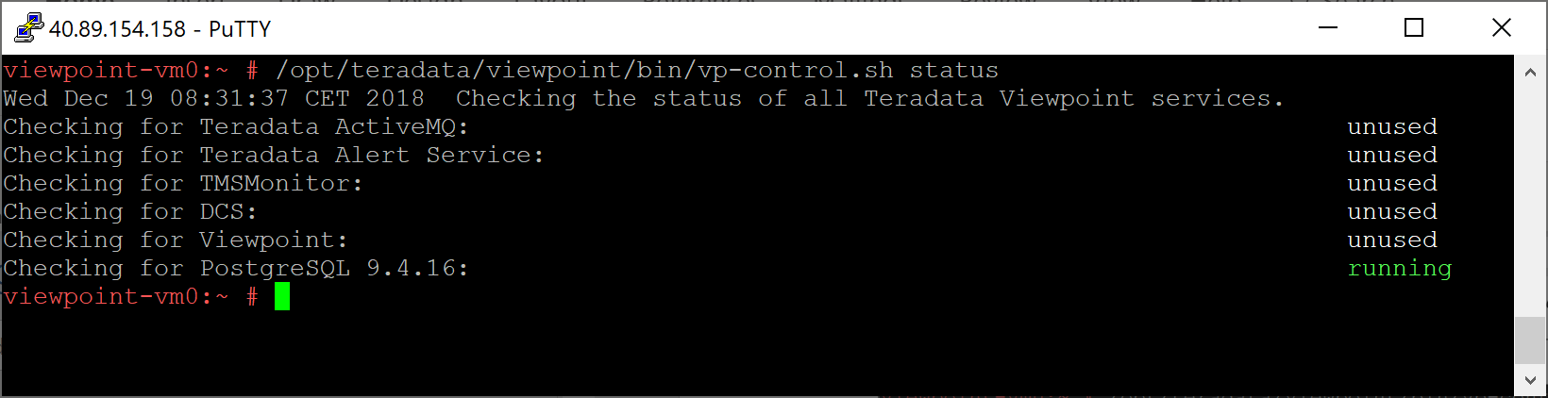

Now you can exit the PuTTY session: *exit*.

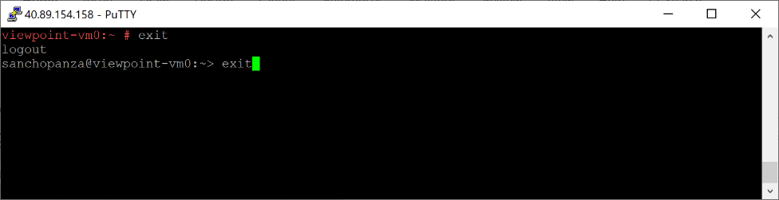

From the Azure portal, stop the virtual machines associated with Viewpoint.

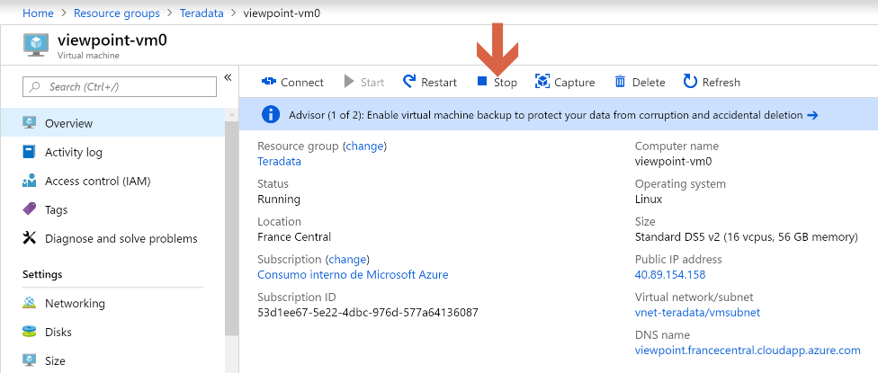

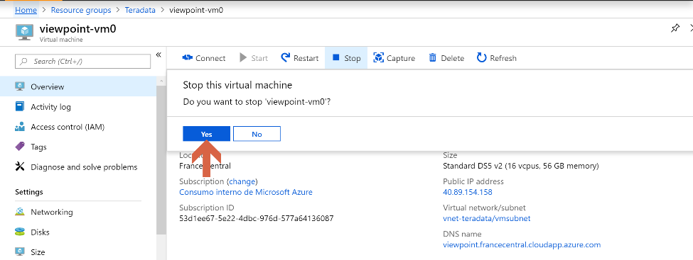

## How to resume working again

### Teradata Vantage

From the Azure portal, start the virtual machines associated with Teradata Vantage.

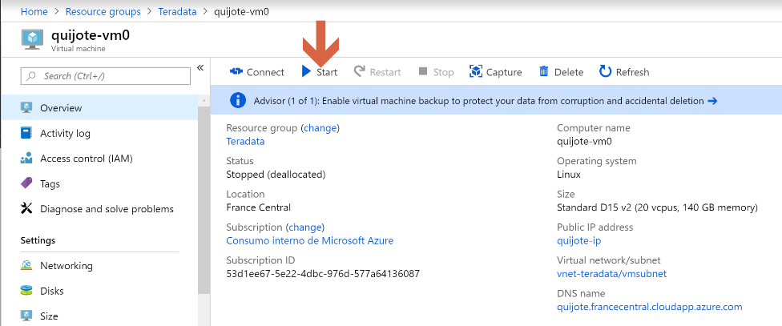

We take note of the public IP address and the DNS name:



Now we connect to the node operating system. To do it, we are going to use [PuTTY](https://www.putty.org/), which is used to secure remote shell access to a Linux system. If you don’t have PuTTY installed on your computer, you can download it from [here](https://www.putty.org).

We open PuTTY.



Provide the Teradata node (quijote-vm0) IP address or DNS name, and click “Open”.



If the PuTTY Security Alert window appears, click on “Yes”.



When prompted, provide with the OS user and password which you setup in screen 1, section 2.



Switch to the root user environment: *sudo su -*



Verify the database is shut down: *pdestate -a*

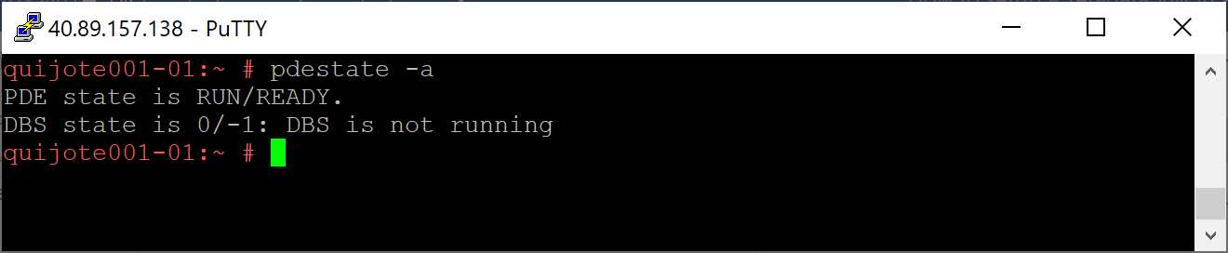

Restart the database: */etc/init.d/tpa start*. Putting the database in this state may take several minutes.

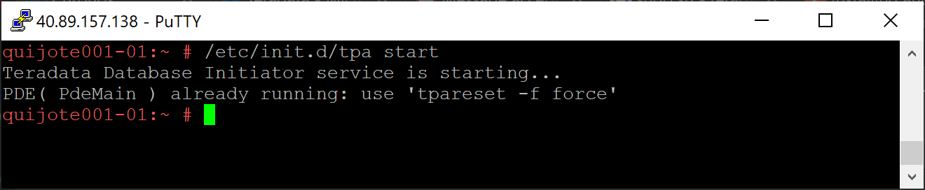

Verify PDE is up and running: *pdestate -a*

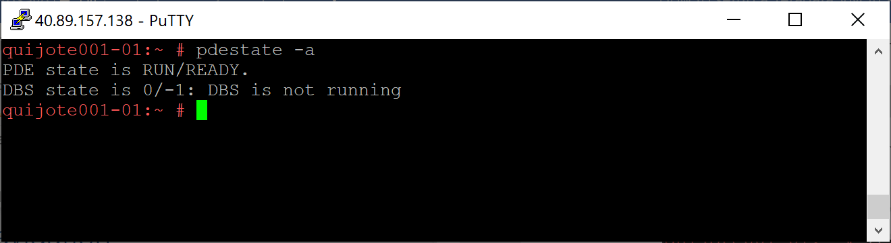

Now you can exit the PuTTY session: *exit*.

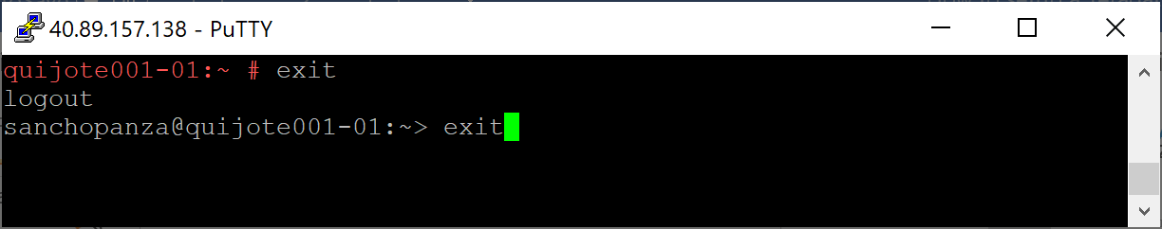

### Viewpoint

From the Azure portal, start the virtual machines associated with Viewpoint.

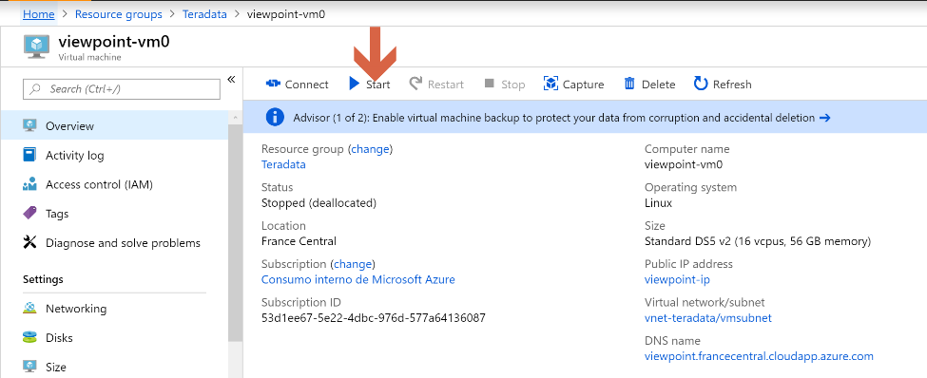

We take note of the IP and DNS name.

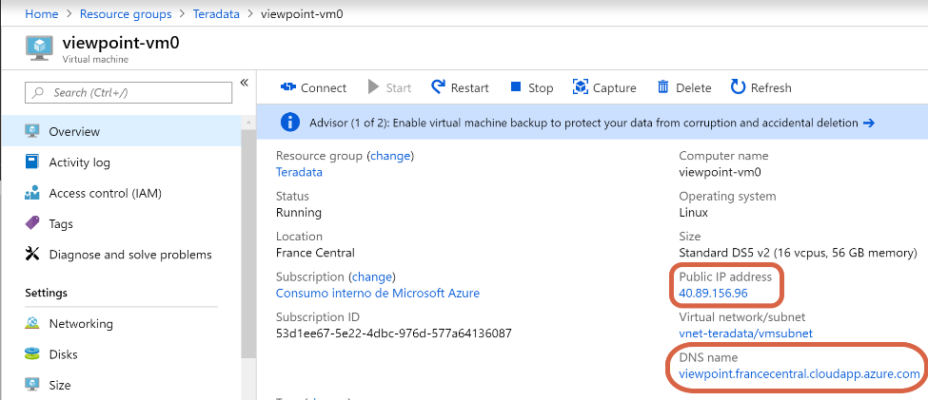

Now we connect to the node operating system. To do it, we are going to use [PuTTY](https://www.putty.org/), which is used to secure remote shell access to a Linux system. If you don’t have PuTTY installed on your computer, you can download it from [here](https://www.putty.org).

We open PuTTY.



Provide the Viewpoint node (viewpoint-vm0) IP address or DNS name, and click “Open”.

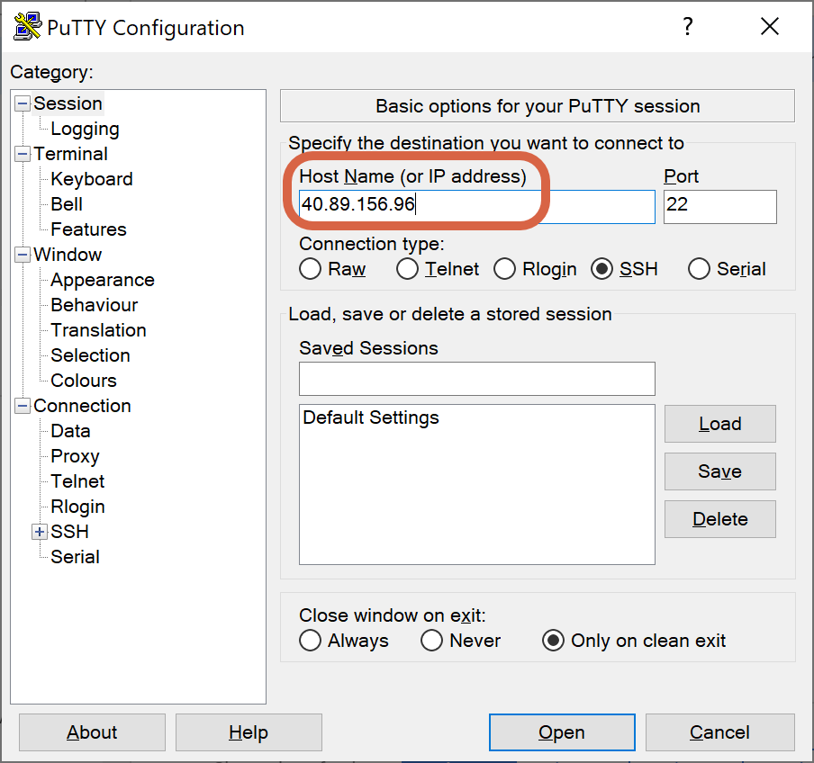

If the PuTTY Security Alert window appears, click on “Yes”.



When prompted, provide with the OS user and password which you setup in screen 1, section 2.

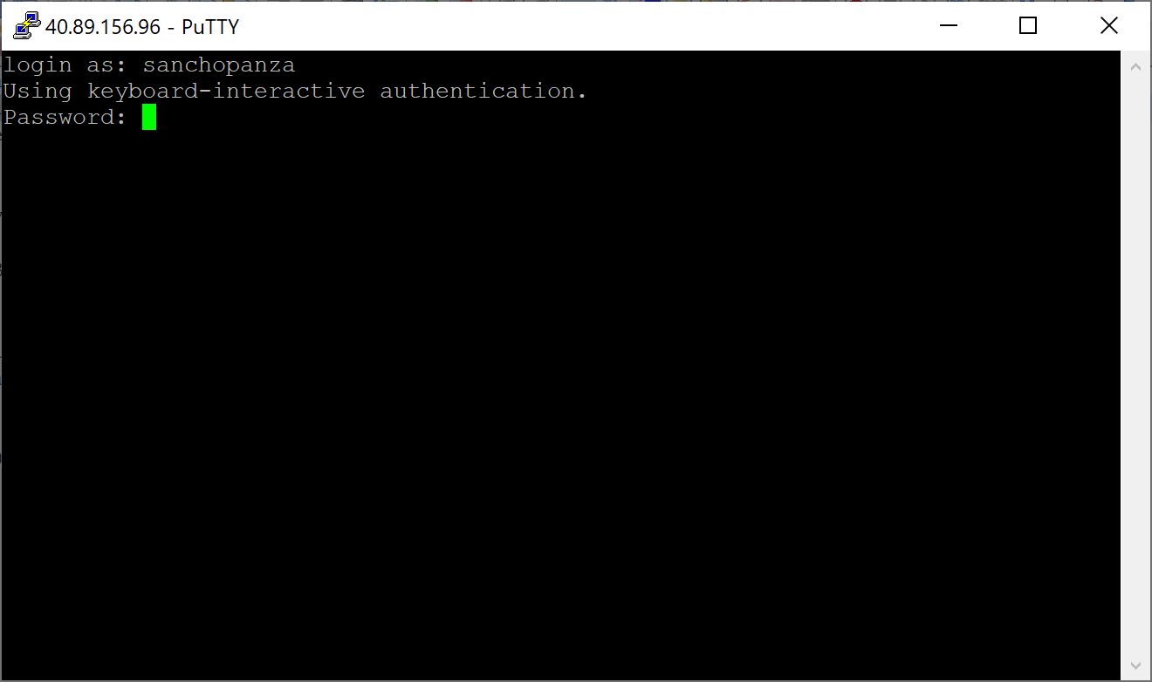

Switch to the root user environment: *sudo su -*

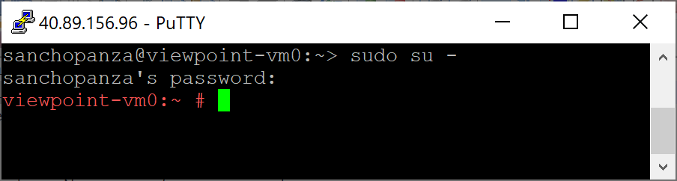

Check the status of the Viewpoint services: */opt/teradata/viewpoint/bin/vp-control.sh status*

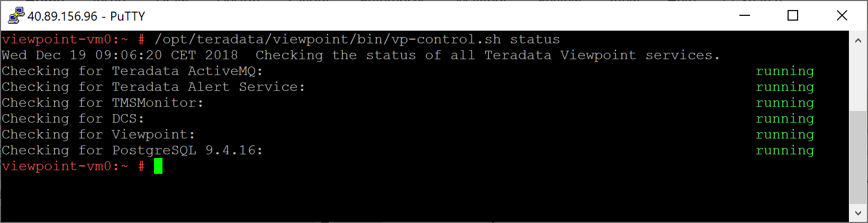

Now you can exit the PuTTY session: *exit*.

